An Exploration into West Cornwall's Maritime People and Working Lives Between (1865-1935): Using Photographs held within Morrab Library's Photo Archive Collection.
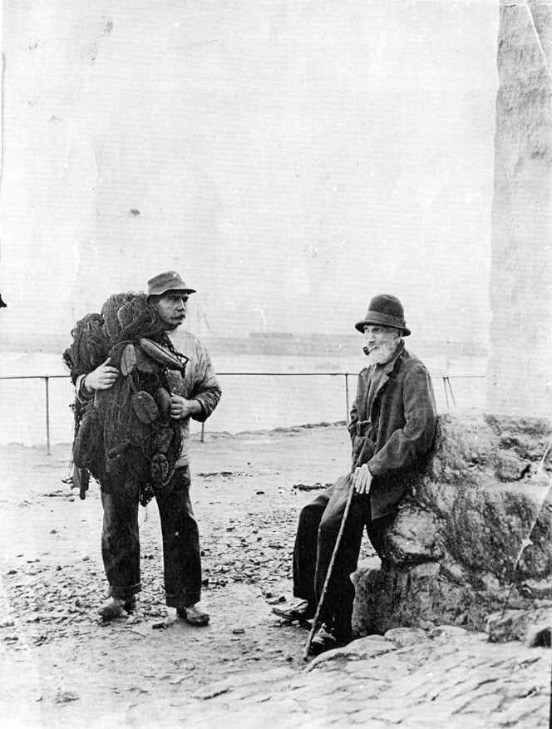
An article written by Samuel Hill as a part of a ESRC SWDTP PhD 3-Month Work placement.

Acknowledgements

I would like to thank the library and photo archive teams at the Morrab Library. For three months, you have welcomed me with open arms and have made me feel very at home in the library. The constant fascination with my research and the constant support you have provided me with my work placement is really appreciated.
All photos used within this article are owned, edited, and digitally held by the Morrab Library Photographic Archive. Links to which are available here: https://photoarchive.morrablibrary.org.uk/

Contents Page
Acknowledgements 2
Contents Page 3
Introduction 4
Chapter One: People 8
Men 8
Women 11
Children 15
Conclusion 20
Chapter Two: Working Lives 22
Fishing Industry 22
Trade and Commerce 24
Tourism 26
Conclusion 27
Conclusion 29
Appendix 32
Bibliography 59

Introduction

As part of my three-month work placement at the Morrab Library Photographic Archive, I set myself the task of producing a short article that demonstrates how photographs held by the archive can be used to explore the maritime communities of West Cornwall. The Morrab Library Photographic Archive possesses over 15,000 photographs donated by the public, with this type of collection process being incredibly beneficial for preserving images that detail local social, economic, and cultural history. The archive has been in operation for over twenty years and is reliant on a team of dedicated volunteers for the digitisation, categorisation, labelling, and research of photographs donated to the archive by the public. Funding for the archive is achieved through the sale of books and prints, searchable through the library's main website, but primarily thanks to a generous annual bequest from the late library member Dennis Myner, through the Myner Trust. This article has been inspired by the book Working Lives: Images from the Morrab Library Photo Archive, which sought to collate a sample of the archive's photographs that displays people working, resting, or pausing during work to have their photos taken. This book eloquently displays the variety of working lives present within the maritime, agricultural, industrial, mining, construction, and manufacturing industries of Cornwall.
This article shall look to use the photographs held within Morrab Library Photographic archive to explore the maritime communities, their people, and their working lives within West Cornwall between 1865 and 1935. The main theoretical discipline, that of ‘history from below’, is increasingly beneficial for the discussion of working classes people and occupations of West Cornwall’s maritime communities. This article shall use additional academic sources to expand and contextualise the living and working conditions faced by these maritime communities. Additionally, the time parameters of one-hundred years allow the discussion of this article to document the various changes that impacted people and their occupations over the late 19th and 20th century. Similarly, the geographical focus on West Cornwall has been chosen due to the archive containing a large quantity of photographs that detail various communities on the Penwith Peninsula.
As a means of exploring the working-class people and occupations of West Cornwall between 1865 and 1935, this article shall be separated into two chapters. The first chapter shall look to discuss the people of the maritime communities, with the discussion being led by sections on men, women, and children. This first chapter shall look to pose questions like what can photographs reveal about the experience of these groups in the maritime communities of West Cornwall? Can the use of photographs reveal any information about the identities of these people? Can photos uncover the people's sense of belonging to these places? The second chapter’s focus shall be addressing the working-class occupations apparent in the region; it shall look to explore the occupations of fishing, trade and commerce, and tourism. It shall question what these photographs reveal about the nature of work within the region. It shall also consider what conditions people had to face whilst engaging with their occupation. These two sections shall overall aid the discussion of how photographs can effectively explore the working-class people and occupations of West Cornwall between 1865 and 1965.
In terms of historical material used for this piece, photographs shall remain the main primary material used to explore the people and working lives of these maritime communities. The use of photographs in exploring historical subjects has been greatly debated, with most academics raising concerns about the framework and use. Academics such as Penny Tinkler has summarise these various debates and has issued a framework that promotes a beneficial way of using of photographs in social historical research. In her framework, Tinkler identifies that historians should firstly consider the material context of the object of a photograph, as its ‘meaning is inextricably connected to its materiality.’ For instance, a photograph held within an expensive photo frame indicates a desire to preserve and display an image when compared to an image printed onto a mass-produced jigsaw piece. It is the historians' job to explore the material form of the photograph, with awareness to how the image is preserved, the technology used, and the paper printed upon.
Secondly, Tinkler emphasises the importance of recognising that ‘photos are approached as constructions that have complex relationship to the world they depict.’ This means that photographs have been constructed through factors like the photographic technologies capturing the three-dimensional into two and the photographers' choices about what is photographed and how. Finally, Tinkler states that to explore the social world of a photograph, the historian must recognise ‘temporalities that are conjured by the photo; the life of the photo; and the timings of research.’ As such, researchers must consider how photographs serve as a singular representation of the time, whilst also appreciating the biography of a photo over time, and how factors such as the time in which research is committed impacts the interpretation of the photograph.
With this practical methodology stated, this article shall look to adhere to Tinkler’s principles in the following ways. Firstly, the material condition of the photograph will be acknowledged during its discussion. Although most of the photographs within this piece will be from the digitised archive, all photo entries on the online archive have notes of their overall material condition, film, or the paper used to preserve the image. Secondly, when possible, this article will acknowledge how a photographer and their technology have specifically constructed an image to display a certain person, place, or occupation. Finally, the reasons to why this research has been undertaken shall be clearly stated.
This article shall aim to investigate how useful the photographs held within Morrab Library’s Photographic Archive are to exploring working class people and their occupations within West Cornwall between 1865 and 1965. The reasonings behind this focus is directly connected to my own academic interests, being that of maritime working-class history within the south-west. It shall specifically mention whether the archive possess the necessary means of exploring a certain subject, with indication made to which subjects possess both a wealth and dearth of imagery that would support future research projects.

Chapter One: People
The first section of this article looks to examine the photographic evidence held within the archive that displays the people of maritime communities of West Cornwall between 1865 and 1935. To explore this, the chapter shall be examining photographs of men, women, and children with particular focus on themes of identity, experiences, and belonging. In some sections, the chapter will discuss the variety of changes that impacted these groups and how their lives were shaped by the maritime community.

Men
The experience of working-class men living and working within the maritime communities of West Cornwall drew great fascination by the photographers of the era. The period of 1865 to 1935 saw great changes to the experience of men, with the fluctuating conditions of their industries, the onset of the first world war, and the changes to their community all impacting their lived lives. This section looks to explore how photographs captured the working-class experiences and identities of West Cornwall.
The experience of men in West Cornwall can be productively reconstructed using photographs. Historian Joanna Bourke notes that working-class experiences of community were shaped by factors such as people living in proximity, sharing communal spaces, possessing similar occupations and adopting similar identities. Evidence from the photographs supports this understanding whilst also suggesting that a man’s employment tended to shape his lived experience. For instance, most aspects of a man’s identity and connection to a community were directly connected to his occupation, with the vast collection of photographs of ‘fishermen’ within the archive suggesting that photographers shared a great fascination in their experience. Images of fishermen within Figures 1.0, 1.2, and 1.3 demonstrated how men have forged a historic collective identity through the similarities seen in their work clothes, headwear, and facial hair. Much of these similarities, such as clothing, were due to the nature of their occupations, as most men opting for hardy and warm clothes instead of spending their limited disposable income on the construction of an individual identity. Yet, the collection of these images by the photographers of the era tend to reveal that a sense of community was forged through the collective identity shared by these men, with the collective ways of dressing and facial hair being adopted by a broad of age range of men within the community. Failure to adhere to these traditions of dress or facial hair would have likely led to the social alienation of a person within these smaller, traditional maritime communities. As such, photographic evidence implies that the social lives of these working-class men were distinctly impacted and shaped by both their occupation within historic industries like fishing and their communal space.
These communal spaces were arguably essential to establishing a strong sense of belonging to these maritime communities. As Bourke states, communal spaces that were shared and commonly visited were integral to shaping working-class people’s sense of belonging to a certain place. Evidence of this is greatly represented within the photographic archive, with photographers finding interests in the places that acted as the social hubs of the community. These social hubs often acted as a meeting point for men of all ages to sit, talk, and relax during their off hours, with a bench at the top of Old Quay in Newlyn being a popular location. Figures 1.3, 1.4, and 1.5 have been captured by the photographers to show these social hubs, with all three of these photographs depicting a mixed-age group of working-class men sat on the bench. Although all the men are posing for the photograph, some elements of the image allude to the photographer wanting to capture an ad hoc momment as some of the men are seen reading newspapers, smoking cigarettes, and pipes. A notable hierarchy between the men is present within the photographs, as the younger man are positioned upon the outskirts of the bench whilst the older men get the more centralised positions. The photographer is clearly aiming to capture the spaces in which community was forged and maintained. By doing such, they provide evidence to how the shared public spaces of rest, relaxation, and communication were integral for maintaining both a person’s social relationships and sense of belonging to a certain community.
The experience of the First World War was greatly felt by the men of the maritime communities of West Cornwall. Historians G.H and R. Bennett state that Cornwall was directly involved in the conflict, with her ports, seamen, and ships being targeted by the German Navy. Many of the men from these maritime community, such as fishermen, were naval reservists due to their maritime expertise. The losses of such men to the conflict drastically shaped the domestic and economic conditions of Cornwall, with many families, communities and occupations losing men to the conflict overseas. The photographic archives possess a quantity of photographs that show the celebrations of the end of the First World War within Penzance. The celebrations within working-class areas of maritime communities are commonly preserved within photography, with Figure 1.6 displaying a parade of the Naval Contingents through Market Jew Street in Penzance whilst a similar congregation in Figure 1.7 shows celebration of various organisations who participated in helping on the home front. These events allowed working-class communities to congregate and both celebrate men who took roles in active conflict and those who assisted on the home front. These celebrations were also used as spectacles of memorial, with these events prompting communities to remember those who passed or failed to return to West Cornwall. In some cases, these events occurred within more working-class housing areas, as Figure 1.9 displays a congregation of people in Wherrytown underneath a homemade banner that states “God Bless Our Noble Heroes”, which further shows the community’s active celebration of the men who participated in the conflict. For the working-class men of the maritime communities of West Cornwall, these celebrations of their role in conflict would have prompted a variety of emotions, with some celebrating the end of the conflict and returning home whilst some tried to recover from their experience and the loss of their comrades.
The period between 1865 and 1935 brought about a significant period of change for men during the era. The images held within the archive preserve a vast quality of images that illustrate how men in these communities were defined through their distinctive collective maritime identity and communal spaces. The decline of maritime industries during the early 20th century and the impact of the First World War drastically impacted the social, economic, and personal conditions of men in West Cornwall. Although brief, the imagery held within the archive enables the discussion of a wide variety of male experiences within the region.

Women
Much like the men, the experience of working-class women living and working within the maritime communities of West Cornwall was captured with great fascination by photographers of the era. A particular fascination that photographers had with working class women from maritime areas derives from their identity as both housewives and active wage winners. Research from Sonya O. Rose has highlighted that during the late 19th century it was a necessary requirement for the women to perform their domestic duties and to have an income that would support their family; with inability to do so would placing herself and her family at risk of impoverishment. It has been highlighted by Valerie Burton that the ‘fishwife’ was one of the common occupations adopted by women within the maritime communities, with the role seeing women act as boisterous hawkers or sellers of fish. This unique role as a financial provider was of great interest to the photographer Robert H. Preston of Penzance, with Figure 2.0, 2.1, and 2.2 displaying two photographs of older ‘fishwives’ that show that the photographer has used a studio space to produce a suitable coastal background, pose the women with baskets, and ensure they wore atypical ‘fishwife’ attire. These images are of particular interest as they imply that the photographers (Preston and an unknown photographer) wanted to preserve how the identity of the fishwives was defined by the conditions of their work and the clothing, with the choice of older women wearing heavy woollen petticoats and bonnets fitting the popular representations of the Cornish fishwives during the period. Although curated, the organisation of such photo shoots remains highly invaluable for the preservation of this unique and commonly represented type of female occupation within the maritime communities.
Building upon this point, the experiences of the working-class women from maritime communities is reasonably present within the Morrab Library Archive. In particular, the physical labour and experiences of the community of the fishwives are greatly represented in the archives collection. The physical labour experienced by these women is greatly detailed within the archive, as Figure 2.3 and 2.4 showing how a group of women were essential for the transportation of fish in wicker baskets in Newlyn. Despite the role of carrying a vast number of fish through the streets of the town was backbreaking work, these women understood that they played both an integral part in the town's economy and in the transportation of food supplies to the market for local people. Photography of the era continues to illustrate the distinctive social bonds that were established with women in the occupation, with Figure 2.5 showing two older fishwives talking with baskets in hand whilst 2.6 shows the congregation of a group of young fishwives in Newlyn. The experiences of the work for older ‘fishwife’ and fish sellers within the maritime communities are visibly present in the archive's collections, yet there is a limited amount of representation of younger women within other occupations. This is arguably caused by the photographer's fascination with community ‘elders’ continuing to partake in occupations that represented a bygone era. Despite this, the photographs collection of these images is incredibly beneficial for exploring this commonly seen female occupation within the maritime communities of the 19th and 20th century.
Additionally, the photo archive possesses a varied collection of imagery that defines the domestic lives of women within the maritime communities of West Cornwall. The photography of working-class women’s occupations and domestic lives during the late Victorian period was stated by historian Sarah Edge to have been an ‘experiment’ of photographers who were engaging in the “social reportage and pictorial journalism’ of an underrepresented class. Arguably, these experiments have provided current historians with a plethora of material that represents the day-to-day activities associated with women's domestic duty within rural maritime communities. Evidence from the archive continues to present some examples of this, with Figure 2.7 showing two women talking to one another outside a house in Mousehole, with one woman carrying two buckets of water to the well, whilst Figure 2.8 displays how women were watching their children sitting and playing on the streets of St Ives. Interestingly, Figure 2.9 provides an insight to the social occasions that made up parts of the woman's day, as the image shows two smiling young women chatting whilst taking a break from organising goods within a large basket. These images possess an immense amount of value, as although they appear mundane, the photographs effectively capture these small chores and the occasions of socialisation that made up the domestic roles of women better than any other source or document type. Arguably, the photographer's collection of these images from smaller maritime communities bucks the trend of photojournalism during the period, with Edge stating that larger urban or industrial communities tended to be the more representative of photographed working-class women. As such, great value must be placed in Morrab’s collection of imagery that displays the variety of domestic duties of working-class women from maritime communities.
The analysis of photography centred around women of the maritime communities of West Cornwall has revealed both some strengths and weaknesses of the archive collection. The archive excels in the collection of imagery that displays the identity and working lives of the elder Cornish fishwife. It also possesses a great collection of imagery that displays the everyday domestic duties of women within these communities. Yet, problems arise when attempting to examine other occupations in these communities and younger demographics. This is not an intrinsic problem of the photo archive but instead a problem of the photographers of the era who were destined to capture popular imagery, like the fishwife, that would have gained attention from customers seeking representations of the bygone age of Cornwall.

Children

Much like their adult counterparts, the children of West Cornwall were drastically shaped by their surroundings. The historian of childhood Ginger Frost made note that during the latter part of the Victorian era, the notion of childhood was both lengthened and drastically shaped by the multitude of social, cultural and economic transitions of the latter 19th century. The focus on images of such a group is beneficial for understanding how their childhoods were shaped through these factors, with this study focusing on photographs that detail children’s interactions with the working lives of adults, the natural world, and the ongoing changes seen within the area of West Cornwall. All these factors had a drastic effect on the learned experiences and would have shaped their sense of belonging to the region.
The working lives of adults were an inextricable feature of childhood within West Cornwall between 1865 and 1935. For historians like Frost, the participation of children was an essential way in which ‘unskilled labourers’ generated additional income for their families and how children became educated in the skills of their industries. Many childhoods would have been shaped by the interactions and educational experiences gained through watching and imitating adults participating in manual labour around them. Photographers clearly took a curios interest in this notion, with the archive possessing many images of children from the period that tend to represent playing, resting, talking, and learning within spaces traditionally for the fishing industry. An example of young children within these places is seen in an ad hoc photo in Figure 3.0, with the photo depicting the young girl on the left observing fish within a crate whilst the girl on the right watches two men unloading and sorting their catch. A similar representation is seen in the well-preserved photo of Figure 3.1, which shows a young girl sat on a rock, playing with a stick whilst her older relative is seen hauling in fishing equipment from the sea. Both photographs suggest that some children’s first experiences of play and curiosity were shaped by their relatives or communities participating in maritime industries like fishing.
In some cases, children looked to participate or imitate within these industries from a young age, as either as a form of supplementary income and learning basic skills. The photograph in Figure 3.2 depicts a small boat and three young boys sailing a small fishing boat into the harbour of Newlyn, with the boys on board looking to demonstrate their maturity to the camera by the way in which they are seen to be steering the boat and staring out to sea. Examples of imitating involvement in maritime industries are seen in Figure 3.4, which shows how a group of children have climbed into a boat created by Mr Ellis of Camberwell Street in Penzance. On the left of the image there is a group of boys who appear to be imitating sailors through their stances, whilst the girls to the left adopt more casual stances by simply sitting and appearing joyful within the boat. The way in which these working-class children imitate more adult characteristics of maritime workers suggest what adult inspirations they possessed within these maritime communities. Although one element of the industrial outputs of maritime communities, the continual representation of children interacting or participating within the fishing industry shows what prospects, education, and role models were present for these working-class children.
The natural world of the West Cornish peninsula was an integral feature of many children's childhoods. The unique geography of West Cornish maritime communities meant that, on some occasions, children lay witness to the disasters and natural phenomena brought up by the coastline. The curiosity of children is best demonstrated in the photographic evidence depicting crowds that emerged when ships came ashore or were wrecked on the coastlines of the area. When capturing these wrecks on film, photographers were keen to include the crowds, as it both allowed for scaling the nature of the disasters. For children, these wrecks would have brought both tragedy and excitement to their communities, with the wreck of Jeune Hortense in Figure 3.5 demonstrating the excitement of a large crowd of adults and children to crowd around the vessel at Mounts Bay. A similar scene is present in Figure 3.6, as a large crowd of people has gathered to observe the wreck of the Celecila, with a group of young boys clambering up rocks to examine the destruction of the wrecked ship. The best demonstration of this ingrained fascination with the disasters of the maritime world is seen in the images of the wreck of the RNLI Lifeboat Caroline Pearsons seen in Figure 3.7. The facial expression of the young boys on the left clearly alludes to a shocked yet inquisitive response to the torn-apart vessel present on the beach. Collectively, these images reveal how the disasters caused by the geography of the region and traffic from international shipping routes exposed children to lessons regarding loss whilst also reinforcing the potential dangers of the natural world. For photographers, the wrecks offered a unique opportunity to possess two juxtaposing subjects, with the children’s innocence and curiosity contrasting with the wrecked ship representing man’s inability to conquer the natural world.
Additionally, the natural world brought about the exposure of deceased marine wildlife to the people and communities of West Cornwall. Within a similar fashion, children possessed a morbid fascination with the creatures that washed up on the shores. Evidence of such is captured in a variety of photos from the archive, with postcard images clearly denoting the fascination with creatures from the sea. Postcards seen in Figure 3.8 and Figure 3.9 both continue to illustrate the local community’s fascination with a pod of whales washed ashore in Mount’s Bay, with the central focus of Figure 3.8 clearly demonstrating how children were commonly seen within these spaces during such events. These postcards possess a financial incentive to benefit from a morbid event, but the image also appears appealing to audiences of the time due to the innocence and curiosity of children within the photographs. Non-postcard photographs also demonstrate the innocent reactions children had to seeing such animals, as Figure 3.10 shows how mothers were actively showing children to the body of a Basking Shark in Newlyn Harbour. The young girl on the left seems upset at the animal, whilst the boys to the right have taken an opportunity to observe and even stand upon the beached shark. These images continue to reinforce the unique nature of childhood within these communities, as children were arguably more aware and understood the variety of maritime life. Exposure to such creatures continues to demonstrate how growing up within West Cornwall’s Maritime communities brought about unique experiences brought about by the sea.
During 1865 and 1935, West Cornwall faced a variety of immense changes, with the changing fortunes of the fishing industry, the gradual changes made to towns due to the rise of tourism and the popularity of the area due to the Newlyn Artists. The drastic social and economic changes seen within the area would have had a drastic impact on the children’s early memories, with many of the photographs of such all present. The construction of new infrastructure to assist working-class occupations like fishing was greatly celebrated within the region, with the photographs of Figure 3.11 showing how children took part in the celebrations of the Newlyn North Pier in 1893. The attendance of these children at such an event would have been drastically impacted by their family's connection to the use of the harbour, as those involved in the fishing industry would have wanted to celebrate the construction of such infrastructure. In some cases, children lay witness to the construction of infrastructure out of their class’s reach, as Figure 3.12 illuminates how some poorly dressed children walk past the construction of Penzance‘s Jubilee pool. The drastic changes to a space previously accessible, as seen in Figure 3.13, may have impacted a child’s understanding of whether they had a right to a certain space within the town.
Yet change within the area also brought about interaction with new people and experiences, as the development of the Newlyn Art School brought about an influx of people to the area. Much like the fascination with shipwrecks and marine creatures, children also showed an interest in the artists and the processes of painting, as Figure 3.14 illustrates how two boys are observing the artist shaping and shading her painting of Mousehole. For many working-class children, the influx of artist painting in the open of West Cornwall’s towns and village would have been a significant change of personnel present in these communities. The art produced by many of these artists would have also represented the first time in which these artistic expressions had been experienced by children from the area. As such, the focus on the theme of change continues to show photographers used children’s ‘innocence’ as a contrasting theme to the variety of changes seen within the area.
The childhood of most children in West Cornwall was drastically shaped by their early experiences. Exposure to the physical labour of their parents and community, watching maritime disasters and the morbid arrivals of creatures of the deep, and witnessing the changing fortunes of the region played an important part in the early experiences of children within the region. The archives collection of imagery that details children’s appearance amongst these themes continues to suggest that photographers used imagery of children as a contrasting subject to the experiences of life within the unique maritime spaces.

Conclusion

Using the photographic archive to explore the people of working-class maritime communities of West Cornwall has revealed an array of results for the experiences of men, women, and children between 1865 and 1935. For instance, the imagery held within the library has demonstrated that factors such as identity, experiences, and belonging can be explored to a deep level for each group of people. The archive excels in the representation of maritime working-class identities held by men in the region, with the collection of photographs that display this being of incredible use. Despite this, some areas of the archive fail to produce a broad enough collection of images that specifically show working-class maritime women who were not fishwives or connected to the fishing industry. Interestingly, the exploration of photographs of children is highly useful for exploring the regional changes that defined the experiences of the 20th century. Although some limitations have been recognised, it should be acknowledged that Morrab’s Photographic Archive possesses an extensive collection of photographs that makes the exploration of maritime working-class communities a highly beneficial and fruitful endeavour.

Chapter Two: Working Lives

The second chapter looks to address the working lives and occupations of the maritime communities of West Cornwall between 1865 and 1935. As a means of exploring the subject, this chapter shall address imagery within Morrab’s Photographic Archive that displays work within the fishing industry, trade and commerce, and the tourism industry. It shall look to provide a brief history of what conditions these industries were facing during the period, with the assessment of photographs held within the archive further displaying the documentation of these changes.

Fishing Industry
The fishing industry defined many of the working occupations of the maritime communities of West Cornwall. Yet during 1865 and 1935, the decline of Seine fishing, a once historically essential industry, started to decrease on the shores of the region. The decline was caused by three factors, with Keith Harris stating that the economic dominance of larger industrialised fishing ports within the United Kingdom, the First World War’s decimation of young men to work the vessels, and the technological change to ‘holt bulb’ Bolinder and Kelvin engines all killed of the Cornish Lugger and its industry during the following decades. Although some lugger boats continued to operate during this age of steam and smoke, most vessels that followed the principles of the dominant age of sail and the industries that supported them started to disappear within these communities. Morrab’s Photographic Archive possesses a broad collection of images that display the fading brilliance of West Cornwall’s fishing industry during the latter 19th century. These photographs look to capture the romantic visions of the Cornish fishing industry, with the lugger-laden horizon in Figure 4.0, the stoic men hauling in a net of pilchards in Figure 4.1, and the mending of nets by men on the harbourside seen in Figure 4.2. Arguably, photographers were keen to join the artistic movements prompted by the Newlyn and St. Ives Art School in capturing the romanticised imagery of West Cornwall's fishing industries and communities, with all of the images harking back to tradition forms of manual employment in an age of mass industrialisation..
Yet, the imagery of the fishing industry being connected to such notions began to shift during the early 20th century. As highlighted by local historian John Corin, the fishing industry throughout the early 20th century saw changes to the sizes of harbour infrastructures, the increasing participation of international fishing crews within the area and increasing sizes and propulsion mechanisms of fishing vessels. With these wide ranging changes, photographers sought to preserve the reality of these changes through collecting images that show the ‘warts and all’ of the Cornish fishing industry amid this time period. For instance, Figure 4.3 depicts the capsizing of Our Lizzy, the PZ 109 Lugger that capsized within Newlyn Harbour. The decision to capture such an image was a deliberate choice of the photographer, with the subject of a sailing vessel operating and capsizing in an ‘age of diesel’ being symbolic of the changing technologies of the industry. The continual collection of images that break the romantic ideas of the late 19th century are apparent in Figure 4.4, which shows a man struggling to prepare fish without being attacked by seagulls, whilst Figure 4.5 displays a crew of frustrated fishermen examining their broken ketch, which continues to signify the fishing industry’s unglamorous reality. These changing perceptions of the industry, with photographers aiming to highlight the hardship and the unglamorous realities, act in complete contrast to the simplistic and romanticised imagery produced within the late 19th century. The decision to capture such imagery contributes to a wider acknowledgement of the relative difficulties of certain maritime labour forces within the early 20th century.

Trade and Commerce

Trade and commerce were a common feature of the maritime communities of West Cornwall as these spaces became essential for the trading of international goods, minerals, domestic items, and agricultural produce. In a study on the ports and harbours of Cornwall, Richard Pearse highlights how Penzance remained an important centre of international and commercial trade throughout the 19th century, but the town shifted its focus to the sale of domestic and tourist centred items by the 20th century. Examples of these types of commercial endeavours are apparent in Figures 5.0 and 5.1, illustrating typical shopfronts and markets of the era, with these figures deriving from Market Jew Street, Penzance. The thatched building, being both a butcher and a fruit grocery, possesses a typical street scene for the market town of Penzance, whilst the market scene also demonstrates a crowd of people examining the produce on the variety of stalls. Not all scenes of trade and commerce were not purely contained to stationary shopfronts or market; some were transient forms of commercial enterprises that required charism and fortune to sell their wares. For instance, fish jowsters or fish hawkers, as seen in Figures 5.2 and 5.3, were commonly seen selling locally caught fish along the streets of Newlyn and Penzance. Similarly, Figures 5.4 and 5.5 illuminate how new sellers were to attract the money of travelling tourists, with the small musical congregation around “May Hornes” and the ornate splendour of the ice cream cart being irresistible to men, women, and children travelling within the area. Collectively, these images reveal a collection of ways in which working class communities sold and bought product within maritime communities, with recognisable, familiar, and sometimes unique ways of selling being commonly adopted by sellers in West Cornwall.
On the other hand, some smaller towns like Newlyn, Mousehole and St. Ives were highlighted by Pearse to have been consistently involved in the commercial trade of fish stocks like pilchards, mackerel, and herring. Historians such as Tony Pawlyn have highlighted how technological and infrastructural changes within the region had seen fish brought in by tons rise from 7,000 tons in 1879 to 27,500 in 1905. As a means of selling this fish towards customers or retailers, fishermen and their crews had to actively partake in the selling of produce on the harboursides of maritime communities. Photographs taken within these commercial centres illustrate the theatre that came with selling fish within these communities, as Figures 5.6 and 5.7 illustrate the large group of people from St. Ives gathering to watch the theatrics of selling fish to the public. The photographer has aimed to capture the way in which the fishermen show the crowd what fish have been caught, as the methods of selling hark back to or mirror an era when the Cornish fish jowster was a primary method of selling fish to the local population. In some cases, the photographer has captured the anticipation of people on market day, with Figures 5.8 and 5.9 displaying a collection of people stood around waiting for produce to arrive and for customers to start purchasing goods. The contrast between both sets of photographs is particularly useful for considering the ranges of emotions that working fishermen would have felt on market days, with both anxiety about how many of the fish would sell against competitors, boredom of waiting for goods, and the excitement of selling produce to local people. These photographs again widen our perception of trade and commerce, as they vividly depict the excitement, anxiety, and potential boredom felt by fish sellers within West Cornwall.

Tourism

Although tourism defines the economic output and social conditions of modern West Cornwall, the county was one of the later to develop its accommodation for such an industry. Historian Philip Payton highlights that Cornwall saw its tourism industry develop during the early 20th century and not during the early 19th century like its neighbour Devon. For Payton, although attempts at welcoming tourists to the region had occurred in vast infrastructural changes to towns, with the creation of Penzance’s Promenade in 1844 and the completion of railways to the region by 1859, the region failed to attract a large number of tourists until the 1900s. Images within the photographic archive reflect the early onset of tourism to the region, as large collections of photographs demonstrate the considerable changes in infrastructure and buildings. The most effective way to examine the working lives of the working class is through images that detail occupations connected to the transportation of tourists. The onset of a new travelling population provided a new working opportunity for people to benefit from the changing transportation infrastructure of the area, as the role of a coach driver became a job for members of the maritime community. Images from the photographic archive demonstrate the popularity of the horse-drawn excursion, with Figures 6.0, 6.1, and 6.2 showing the Lands’ End excursion coaches with a great quantity of people onboard. Analysis of these images implies that the photographers took great interest in the driver’s willingness to drive the coach with these many personnel onboard. In many cases, most photographers made these coaches a centre subject of the drastically times in Cornwall, with Figure 6.3 representing how well-dressed, middle-class tourists were becoming more present within maritime working-class communities like Newlyn. The blossoming nature of tourism during the early 20th century offered new opportunities for employment, with the role of a tourist coach driver being a new product of this industrial shift.

Conclusion
Photographic evidence from Morrab Library’s archive details that change defined the working lives and occupations of the maritime working class of West Cornwall between 1865 and 1935. The gradual decline of the age of sail that defined West Cornwall’s fishing industry, the change from a market town of international materials and caught produce to consumer commodities, and the onset of the tourism industry drastically reconstructed the economic opportunities of the region. Photographers of the era produced photographs that eloquently detailed these changes, with some images detailing the sometime ugly nature of maritime employment, the bygone methods of commerce, the new forms of advertisement, and the contrast between a touring urban middle-class and a maritime working class. As such, the potential benefit of more expansive research into these occupations can be determined through this small research project.

Conclusion

This article has looked to demonstrate the use of Morrab Library’s Photographic archive and photographs more generally for the exploration of the working-class people and their working lives within West Cornwall between 1865 and 1935. Throughout the article’s use of photography, the neat methodological and theoretical thinking of Penny Tinkler was consistently addressed to allow for the fair examination of photographs produced during the period. Adherence to such methodological parameters has allowed for integral factors such as a photograph’s material context, a photographer’s input on the image captured, and the singular representation of the image to be carefully considered throughout the discussion.
As a result, the discussion of the photographs held within the photographic archive has recovered certain aspects from its collection. For instance, the photographic archive has provided a broad collection of imagery that makes the exploration of people from working-class maritime communities incredibly effective. The vast collection of imagery of men within these communities provides ample scope for uncovering identities, the social lives, aspects of belonging, and the experiences of post-First World War faced by this group. Comparatively, a similar level of analysis cannot be produced for the imagery of women as most images tended to be focus on specific occupations like the fishwife and on older women. Despite these limitations of the photography, the imagery of women still reveals a good amount of information about the fascination that photographers had with the fishfwives of West Cornwall and the domestic duties seen within these communities. Interestingly, the focus on imagery of children has provided a surprisingly beneficial lens for exploring change within the region. Photographers’ decision to use the ‘innocence’ of children to contrast against experiences such as adult employment, wrecks, the natural world, and the changes seen to the region are incredibly useful for historians analysing these photographs. Overall, the imagery of people held within the photographic archive is a broad, detailed, and unique way in which the people of maritime communities of West Cornwall can be explored.
In a similar vein, the archive remains an efficient way in which researchers can explore the variety of occupations and working lives within West Cornwall. The images that the archive possess are important for the exploration of the fishing industry, trade and commerce, and the tourism industry. The nature of each occupation is beautifully detailed within the photographs collected, with the fishing industry seeing representations that fit both the romantic ideals of the age of sail during the late 19th century and the unglamorous realities that were faced by most fishermen. Trade and commerce in maritime communities are again greatly represented, with the most notable features of these occupations arising from the methods and theatre used by personnel to sell goods. Lastly, the onset of the tourism industry is best represented in imagery that shows the large adaptations made to towns and infrastructure. This means that other avenues are meant to be explored when examining the personnel involved in such industries. As such, focus on methods of tourist transportation provides an interesting insight to how photographers found great interest in the amount of people using their services and the contrast between an urban middle class and the working-class maritime communities of West Cornwall. Again, the photographic collection held by Morrab Library remains a plentiful source for imagery that best shows the occupations and working lives of people of West Cornwall.
As such, the Morrab Library’s Photographic archive possesses a vastly detailed collection of images that makes the exploration of West Cornwall’s maritime working-class communities a greatly rewarding endeavour. Its collection allows the historian to use a visual way of exploring the people and occupations that were present in these communities. The collection would also suit the exploration of rural and mining communities of the county too, as the overall collection possess an array of imagery that would highlight the key facts of these communities. Thus, it can be acknowledged that Morrab Library’s Photographic Archive possesses a greatly beneficial collection of imagery that makes the exploration of working-class maritime communities a vivid and plentiful endeavour.

Appendix
Chapter One
Men (1.0)
Figure 1.0: Group fishermen outside fish cellar Porthgwarra, 1880.
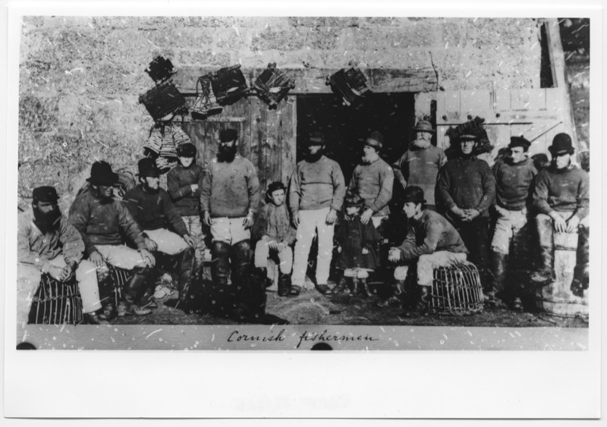
Figure 1.1: Three men, 1890.
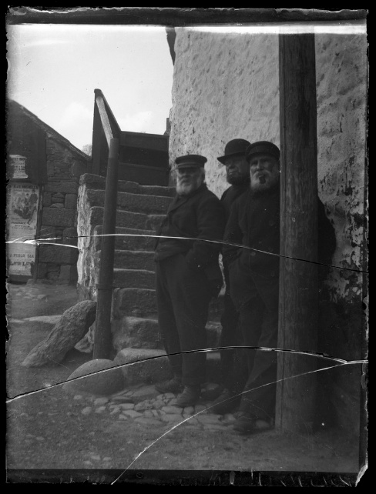

Figure 1.2: Group fishermen and boys,
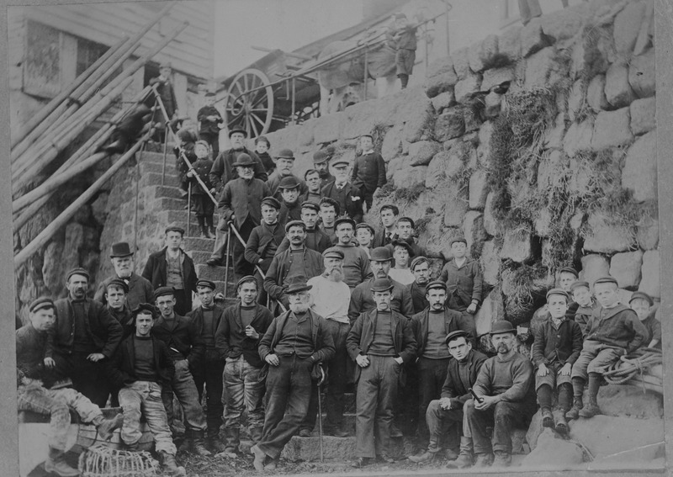

Figure 1.3: Group of young and old men sitting, 1920,
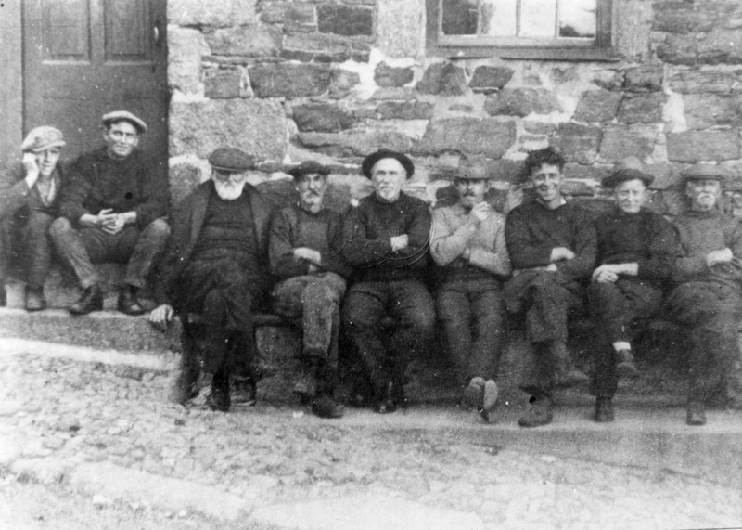

Figure 1.4: Three Fishermen sitting on a bench by a wall, 1925,

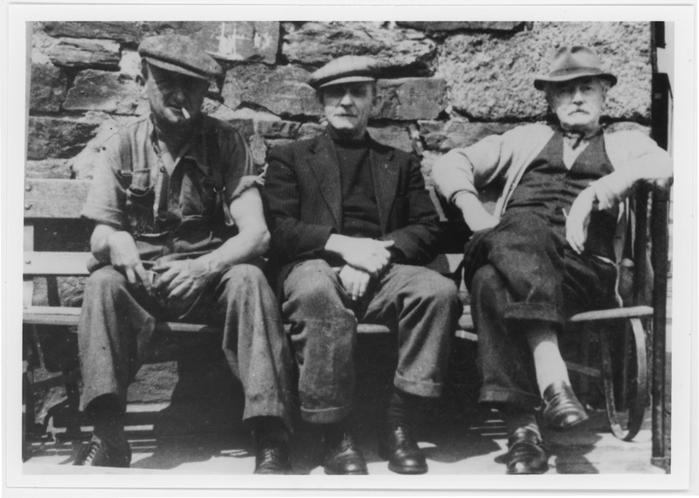
Figure 1.5: Group of fishermen on a bench near old harbour, 1934,
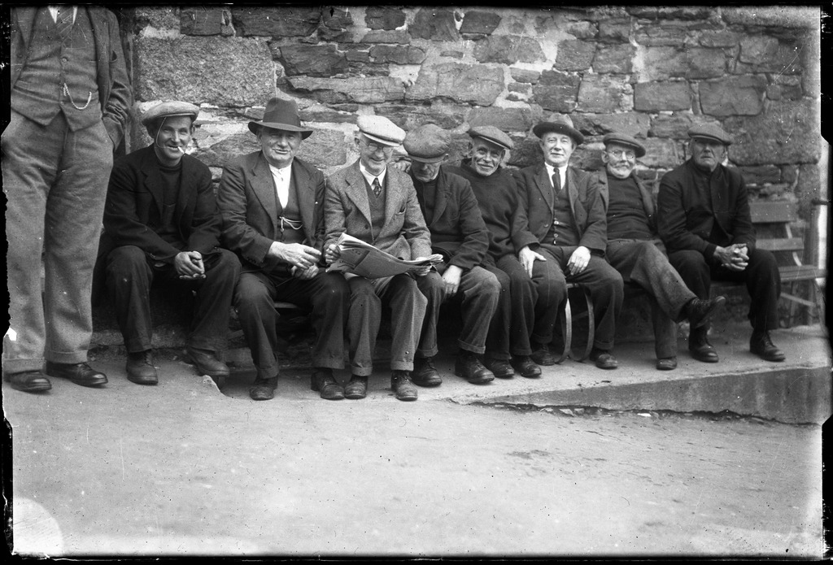

Figure 1.6: Procession up Market Jew Street, Penzance celebrating the end of WW1, 1918,
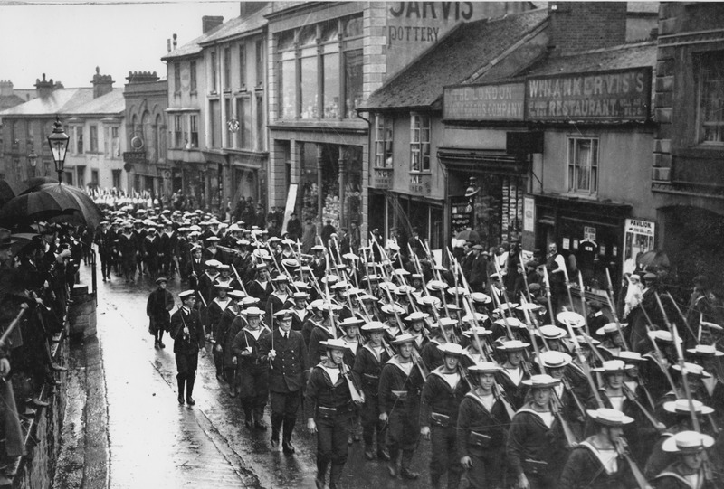
Figure 1.7: Gathering at Alverton St, organisations involved in WW1, 1918,
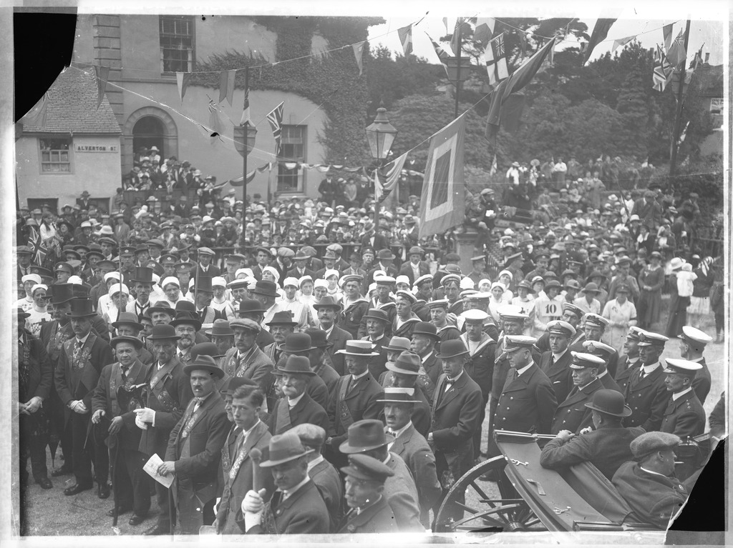

Figure 1.8: Victory Arch Wherrytown looking towards Newlyn, 1918,
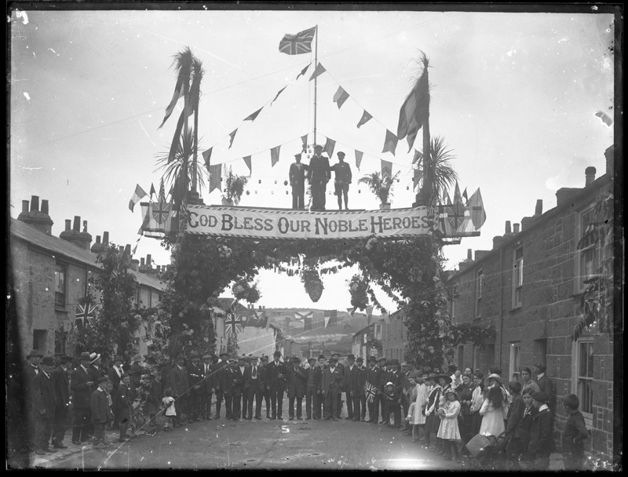
Women (2.0)
Figure 2.0: Robert H Preston, Cornish Fish Woman, 1902-7.
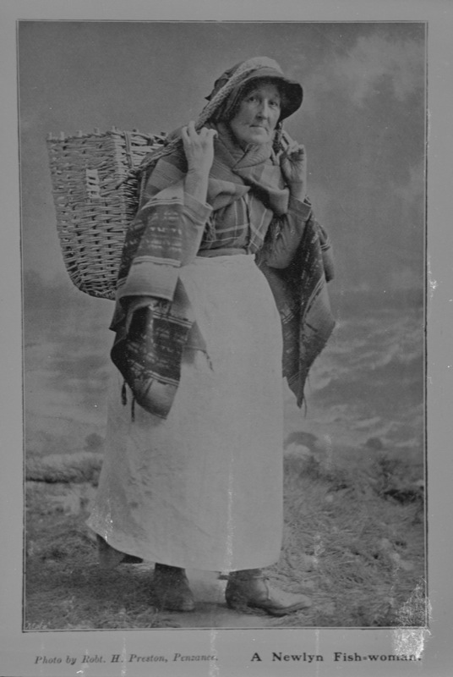
Figure 2.1: Two fishwives, 1870.
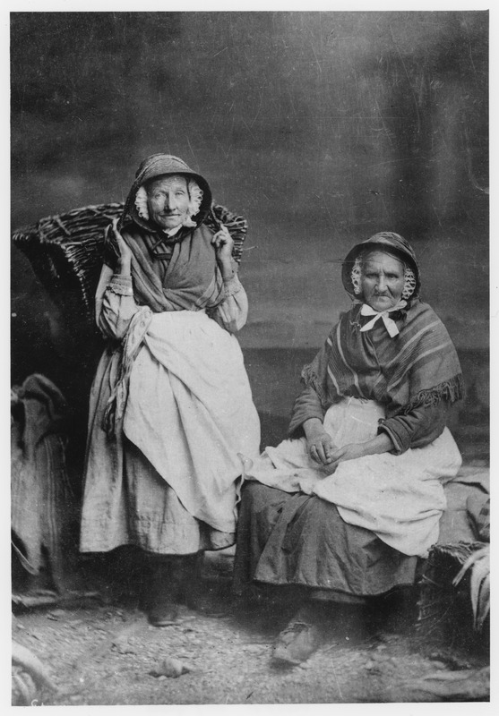
Figure 2.2: Gibson, Cornish Fishwives, 1880.
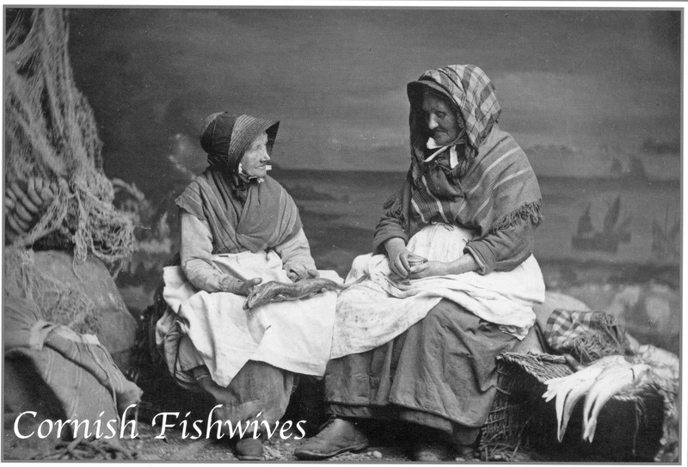

Figure 2.3: Strand area at Street-an-Nowan, Newlyn, 1895-1900.
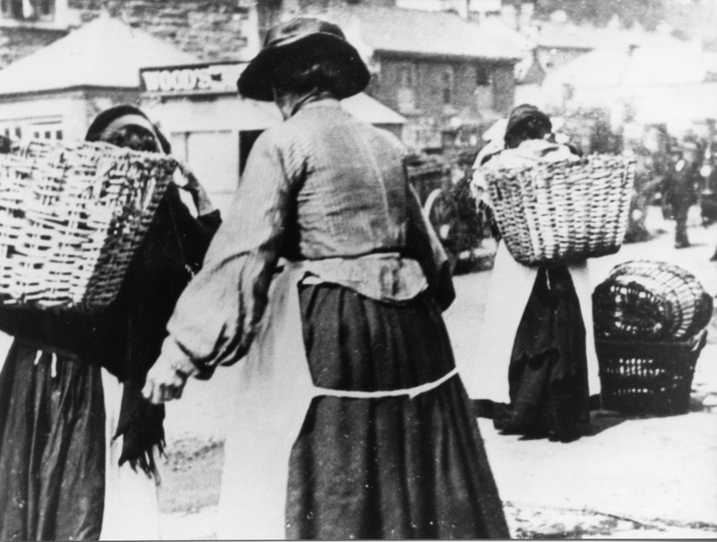
Figure 2.4: Newlyn Fishwives, 1930.
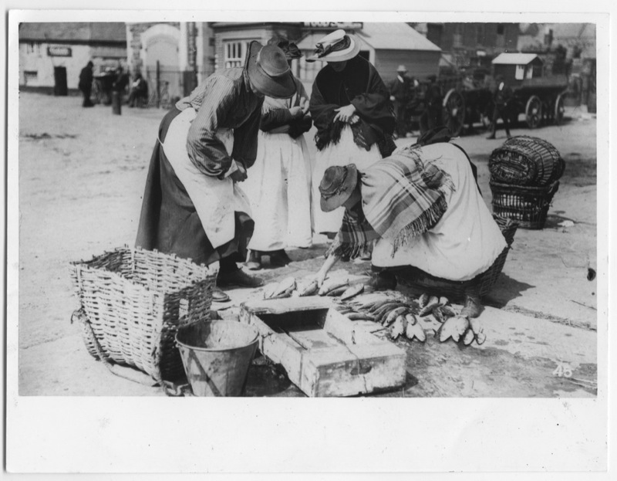

Figure 2.5: Treworveneth St fishwives, 1890.
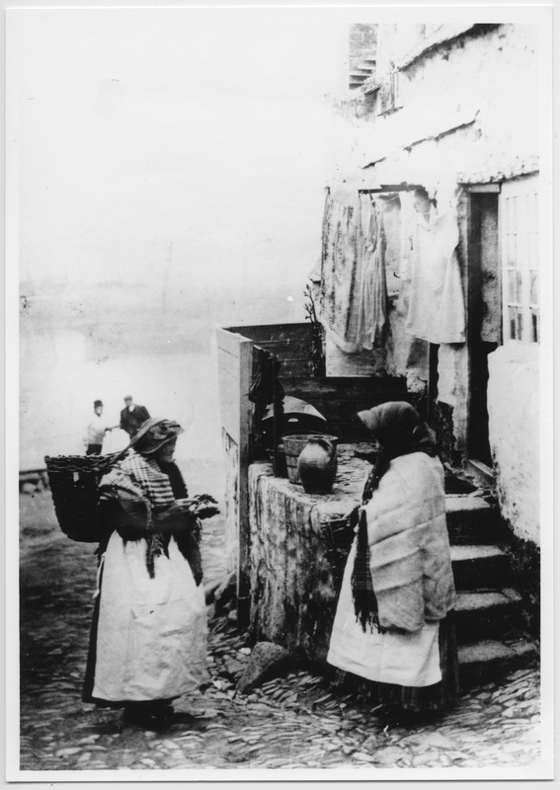
Figure 2.6: Wharton's Series , “Fishwives in Church Street, Newlyn Town, 1907.
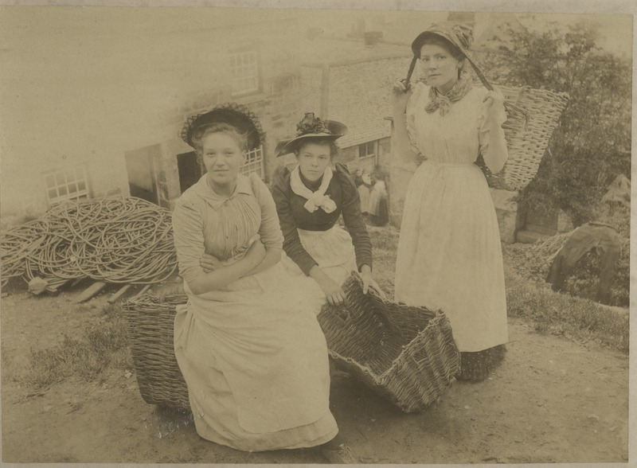

Figure 2.7: Street view.Mousehole. women carrying pails, 1915.
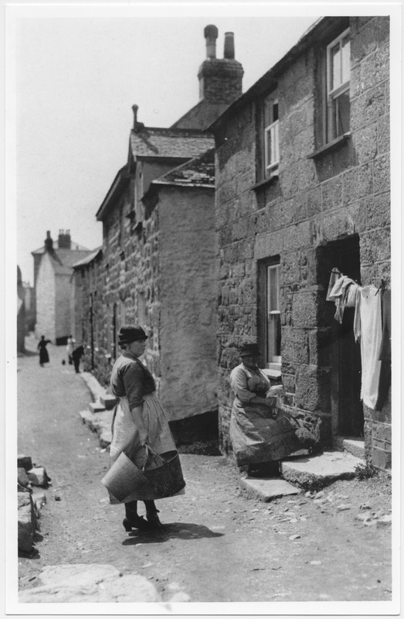
Figure 2.8: Women & Children in The Digey St Ives, 1900.
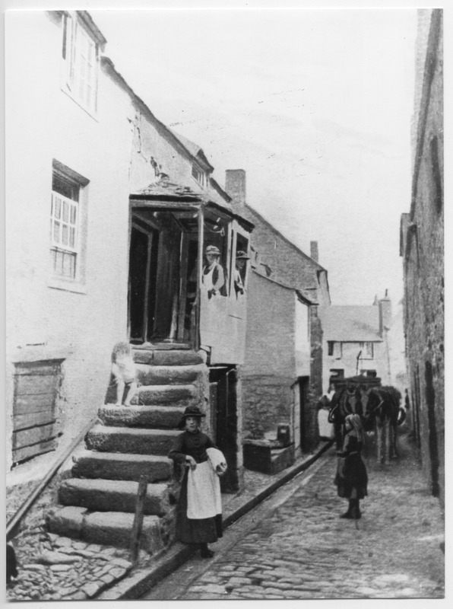

Figure 2.9: Two Women, One Man outside cottage, 1900 (Unknown Date).
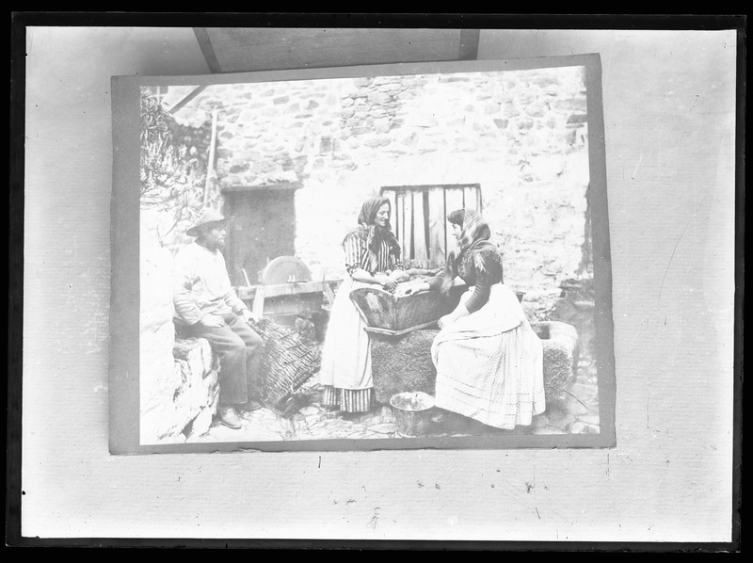

Children (3.0)
Figure 3.0: Landing Fish in Newlyn, 1890.
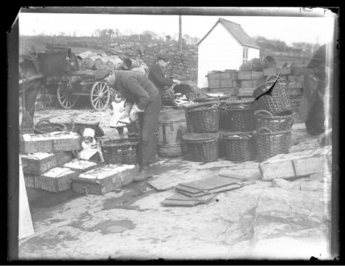

Figure 3.1: Fishermen and Girl on Rocks at Cape Cornwall, 1890.
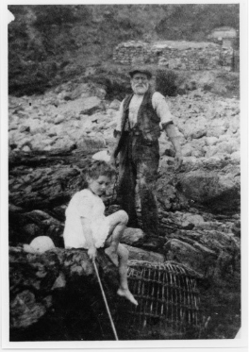

Figure 3.3: Gwavas Quay, Newlyn, 1895
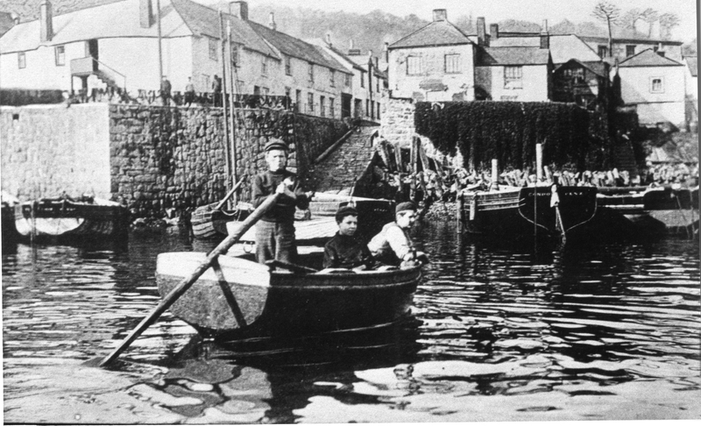

Figure 3.4: Camberwell Street, Penzance. Boat Built in his backyard by Mr Ellis, 1906.
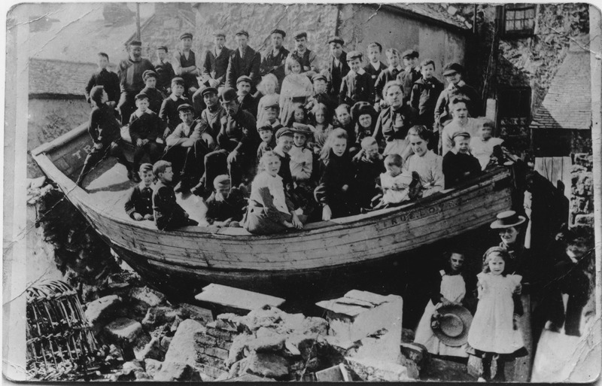
Figure 3.5: Shipwreck the ‘Jeune Hortense,’ 1888.
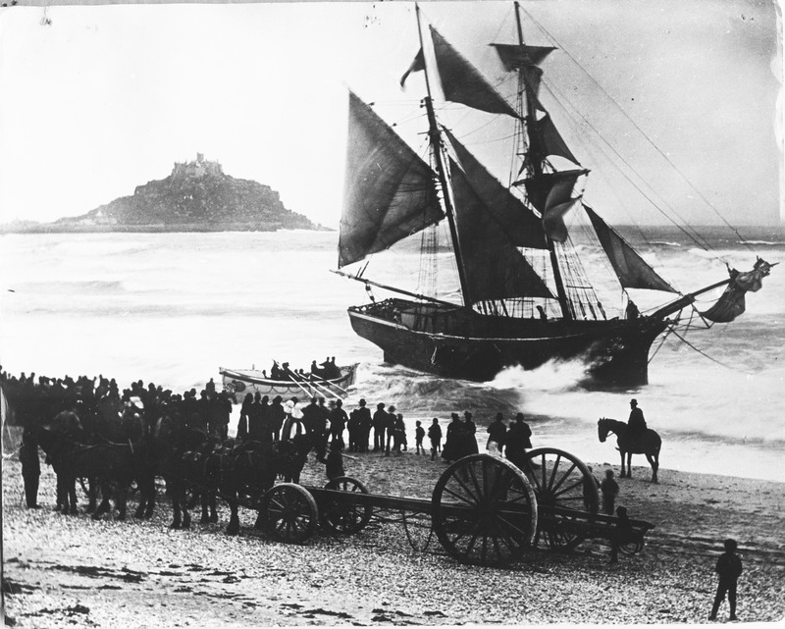

Figure 3.6: Wreck of ‘Cecelia’, 1935.
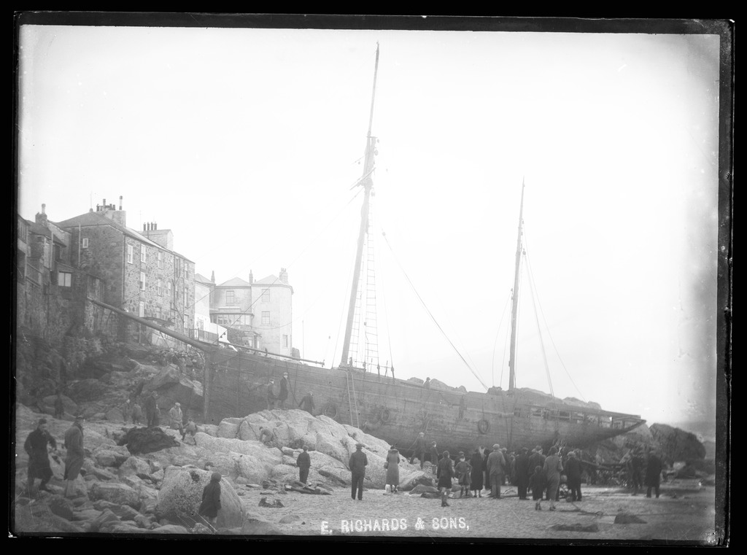
Figure 3.7: Wreck of Caroline Parsons Lifeboat, 1935.
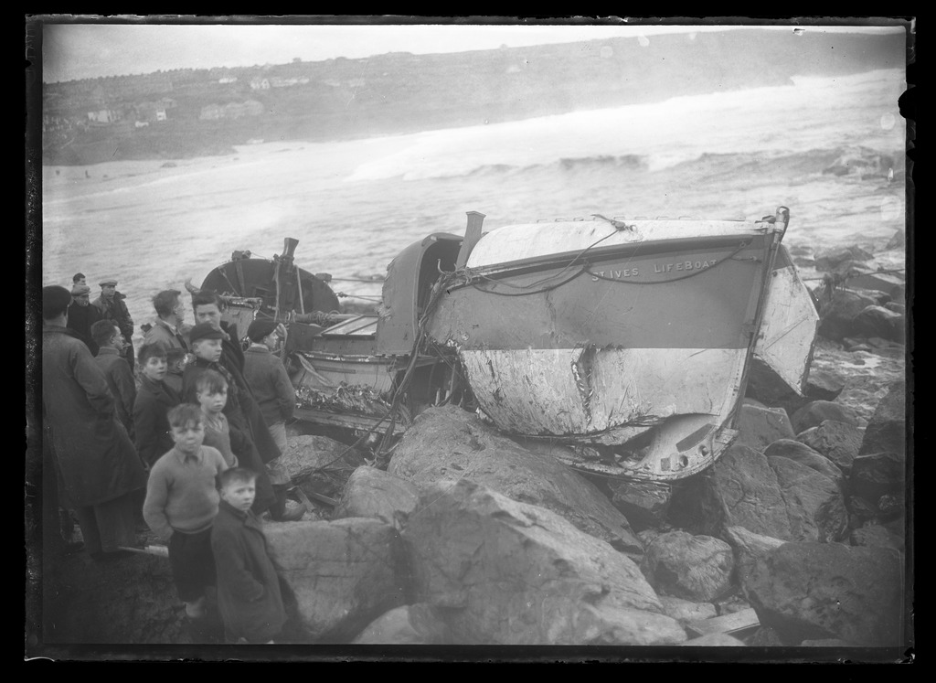

Figure 3.8: Postcard: Whales stranded in Mount’s Bay, 1911.
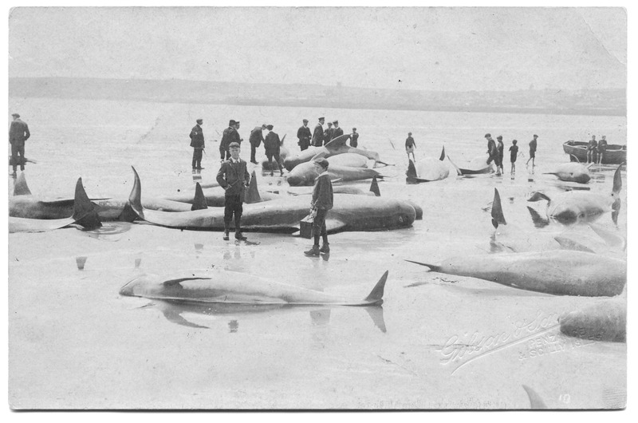

Figure 3.9: Postcard: Whales stranded in Mount’s Bay, 1911.
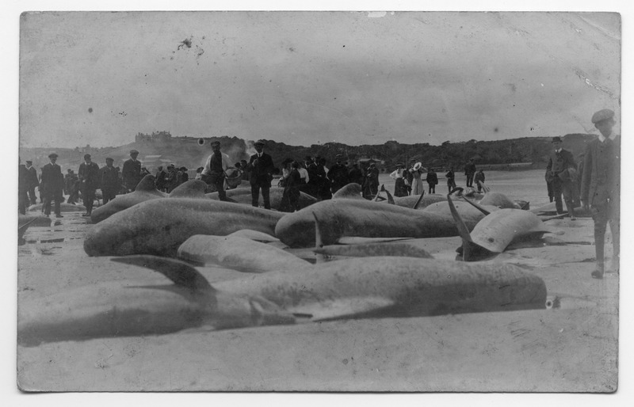

Figure 3.10: Group looking at Basking Shark, Lighthouse Pier, Newlyn, 1926.
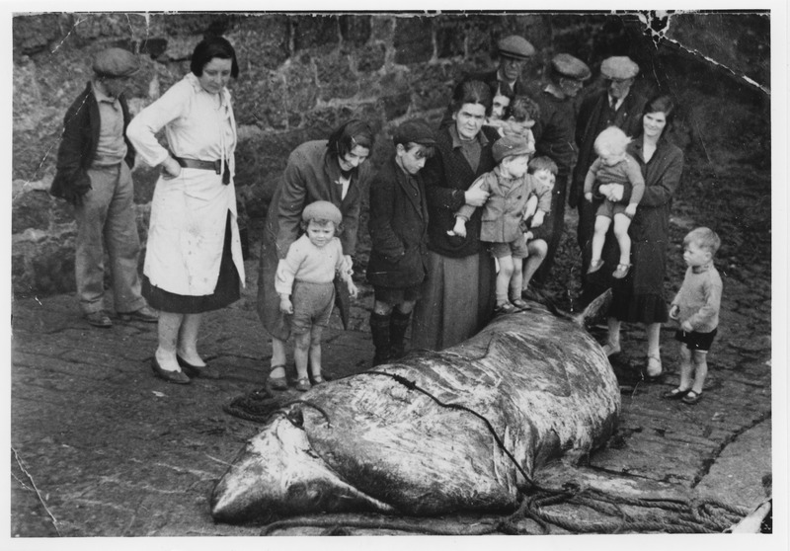

Figure 3.11: Large Crowds Celebrating the Opening of North Pier, Newlyn, 1893.
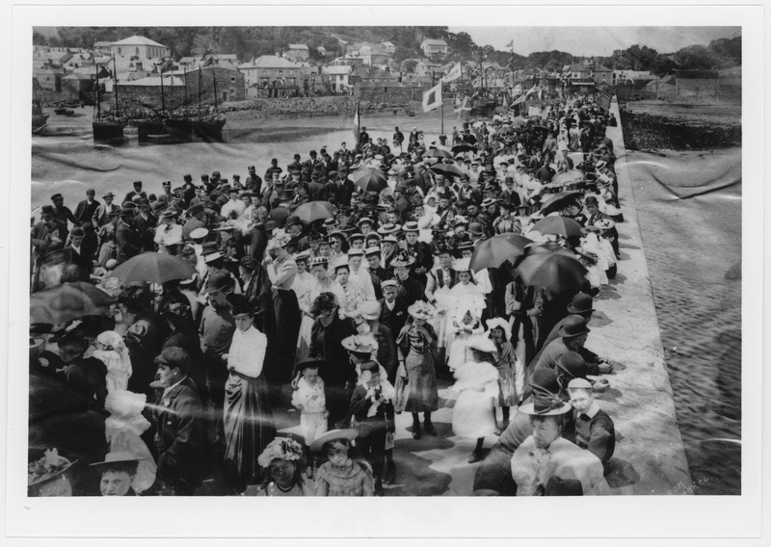
Figure 3.12: Building Sheds and Underwalk which is now part of Jubilee Bathing Pool, 1930s (Unknown Date)
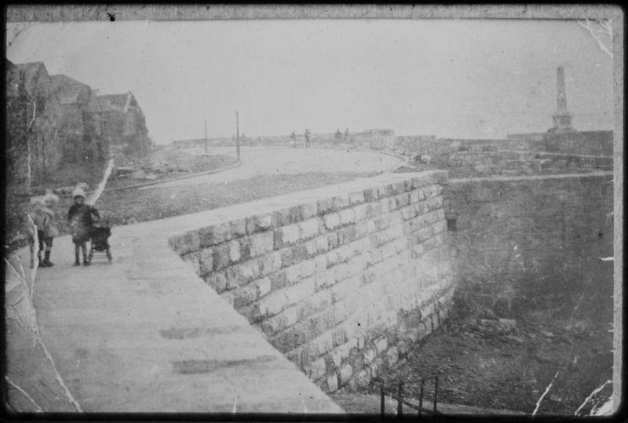
Figure 3.13: Bathers at Battery Rocks before the Jubilee Pool, 1930s (Unknown Date)
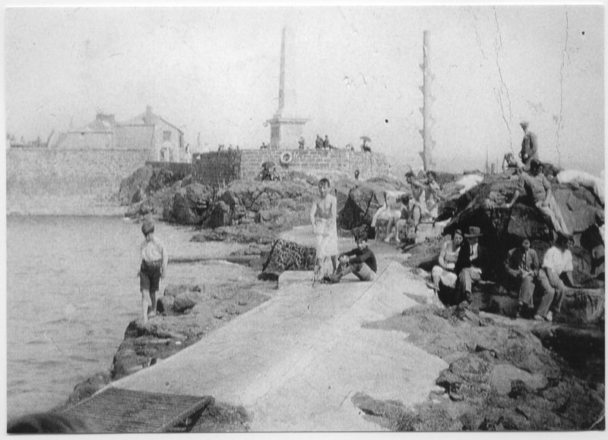

Figure 3.14: People watching a Female Artist in Mousehole, 1930s (Unknown Date)
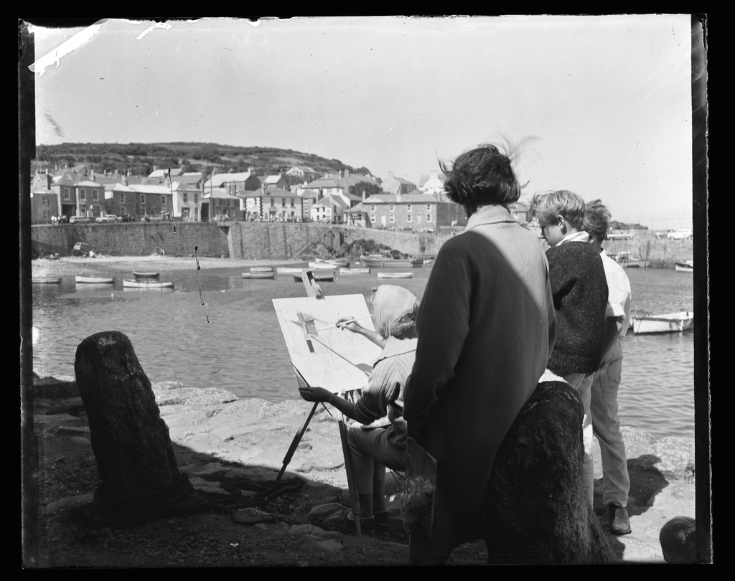

Chapter Two: Working Lives
Fishing Industry (4.0)
Figure 4.0: Newlyn Harbour, 1900.
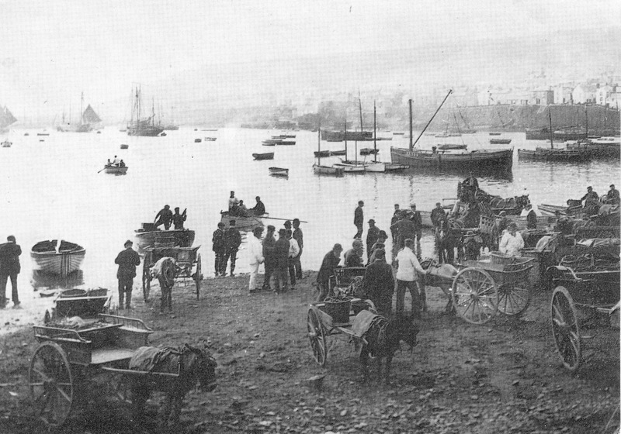

Figure 4.1: Sennen Fishermen clearing a Pilchard net, 1890.
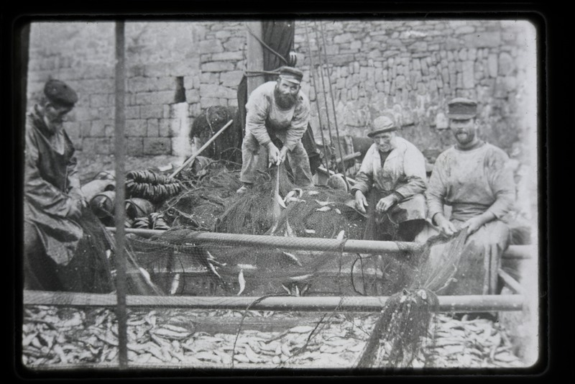
Figure 4.2: Newlyn fishermen mending nets, 1890.
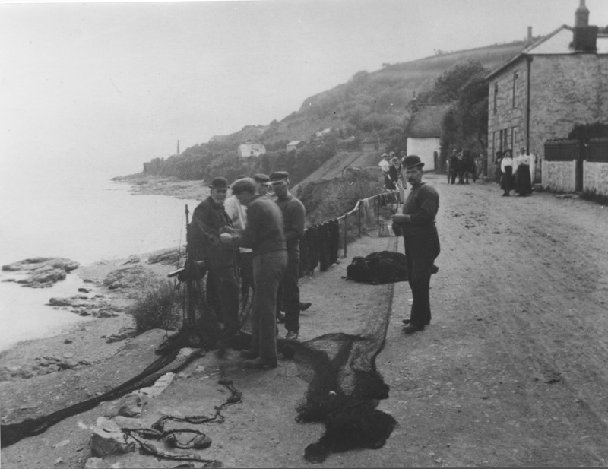
Figure 4.3: PZ 109 Capsized, 1930.
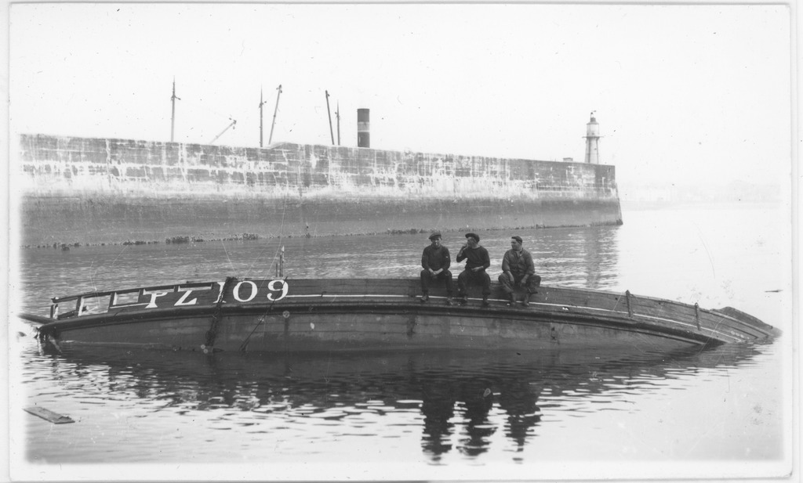
Figure 4.4: Fish preparation with seagulls, Newlyn, 1930s.
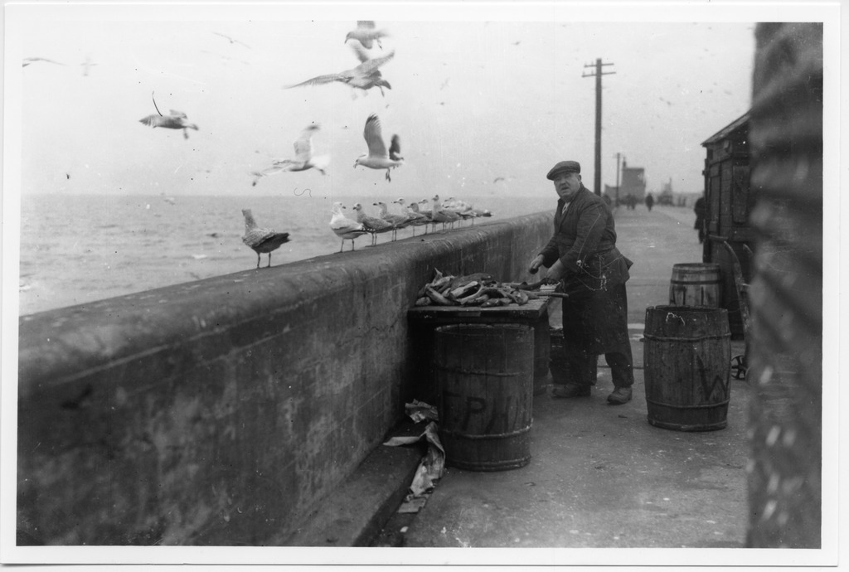

Figure 4.5: Three fishermen on deck of storm damaged ketch, 1935.
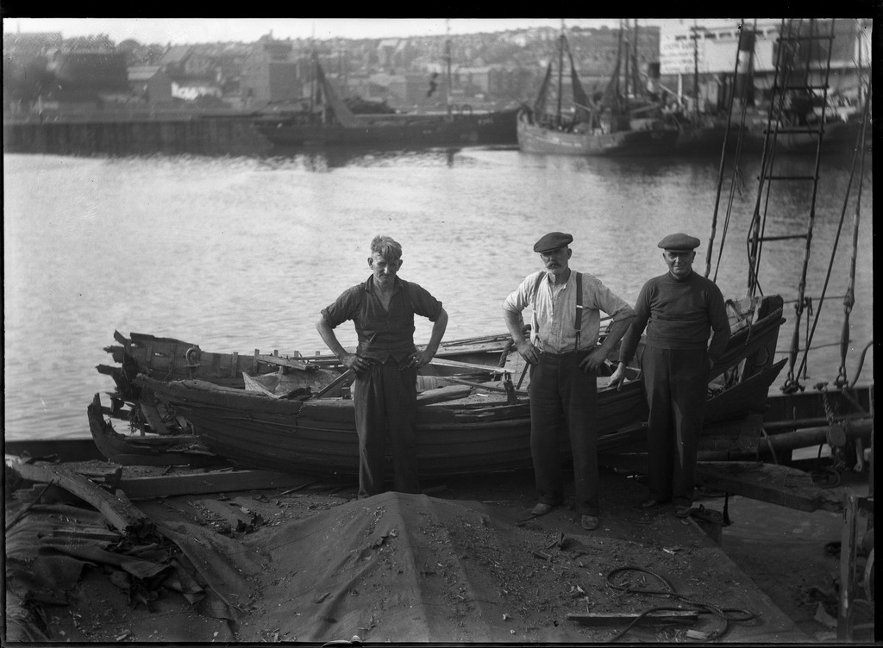

Trade and Commerce (5.0)
Figure 5.0: Thatched Shops in Market Jew Street, 1880 or 1882.
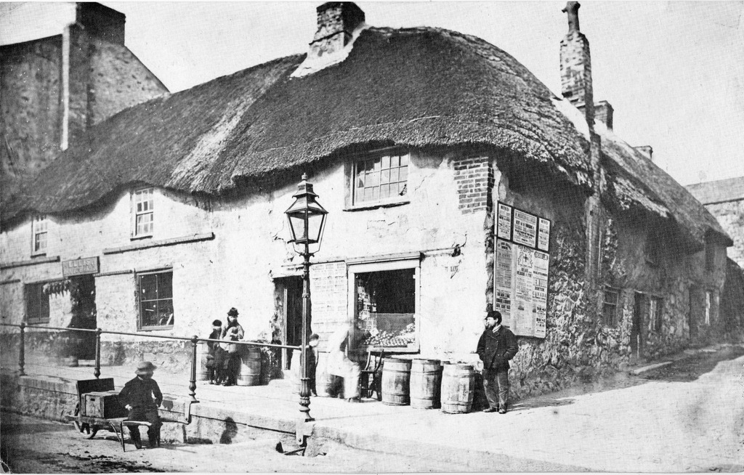

Figure 5.1: Fruit & Veg Stalls alongside Market House,1925.
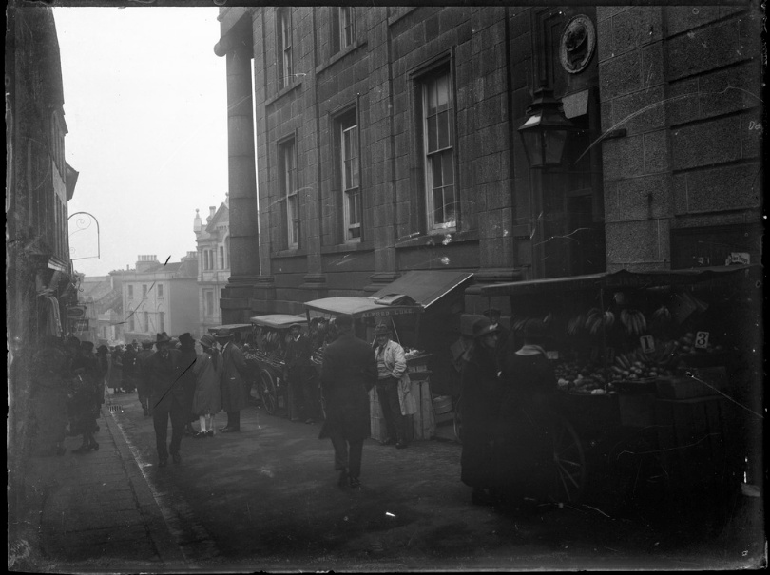
Figure 5.2: Fish Jowster Billy Renfree believed to be member, 1900.
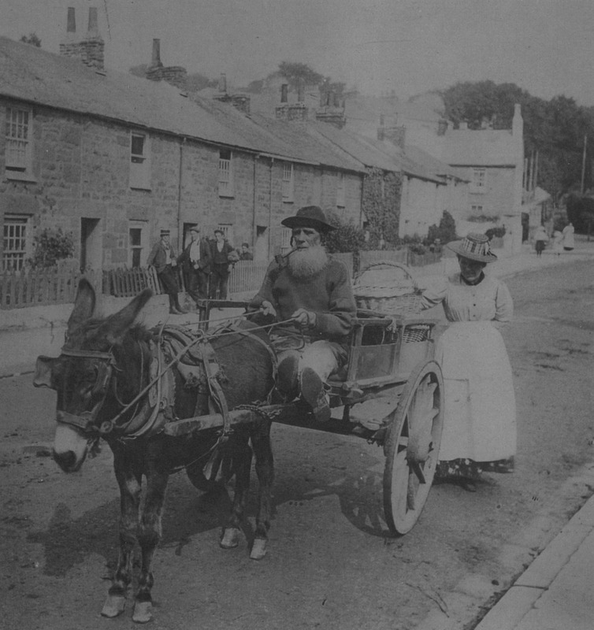

Figure 5.3: Fish Vendor Lizzie Boynes on her Donkey Cart, 1900.
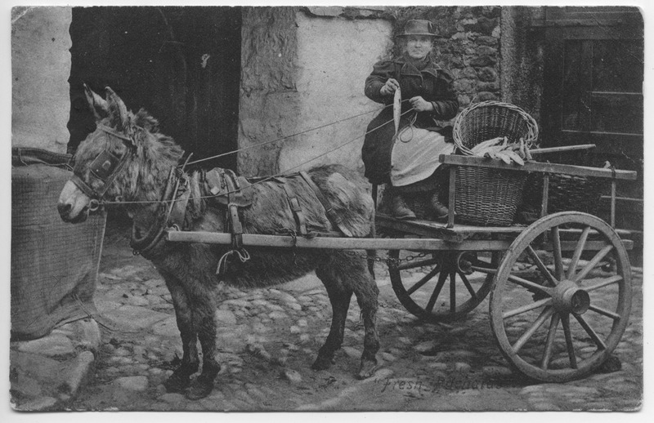
Figure 5.4: May Hornes, Penzance, 1930.
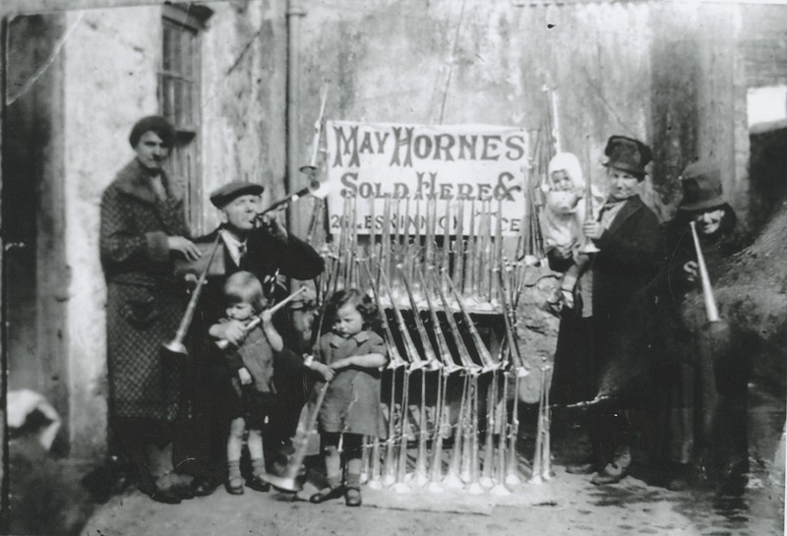

Figure 5.5: Ice Cream Vendor with Hand Drawn Cart Pz Prom, 1920.
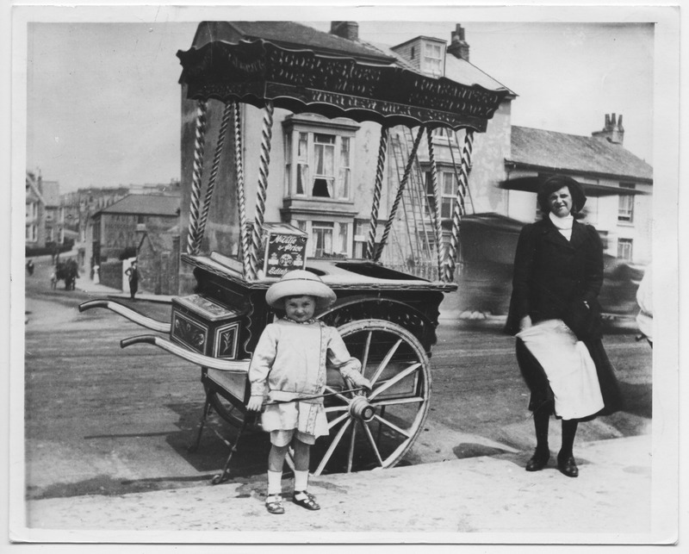
Figures 5.6: Selling Fish from Horse and Cart St Ives, 1935.
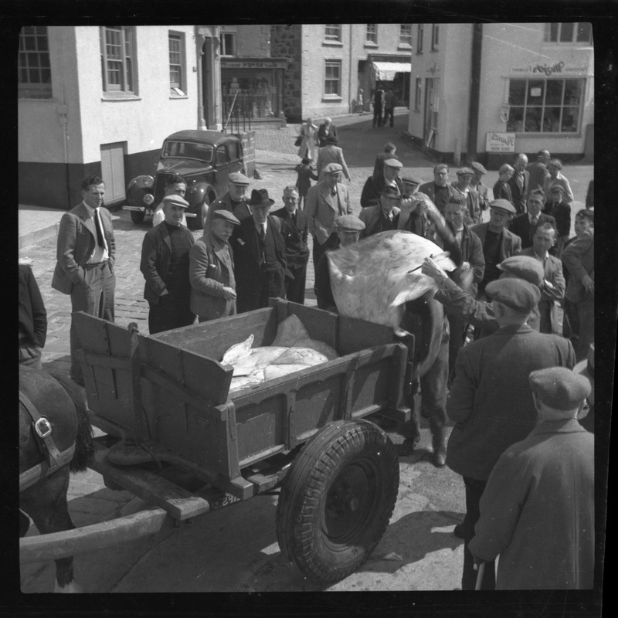

Figures 5.7: Selling Fish from Horse and Cart St Ives, 1935.
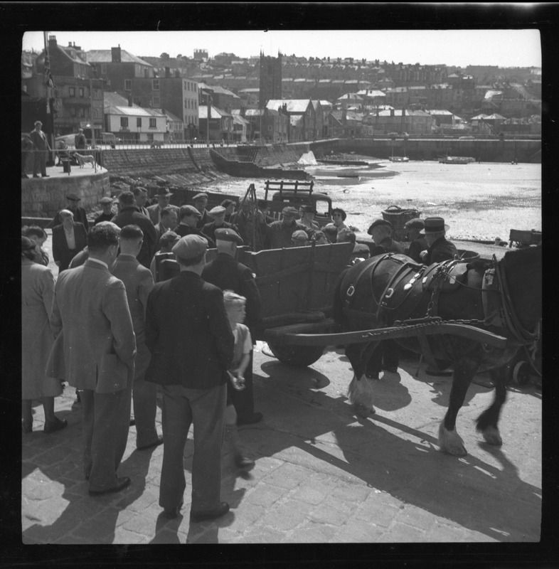
Figure 5.8: Fish Co Offices Newlyn Market Fish Auction Table, 1930.
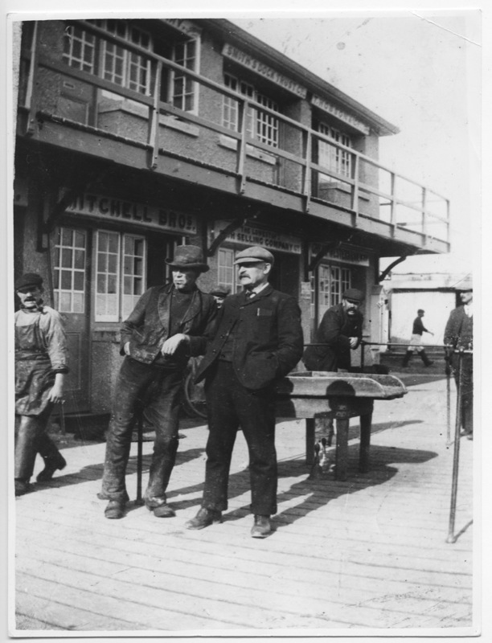
Figure 5.9: Fish Market, 1930s (Unknown Date)
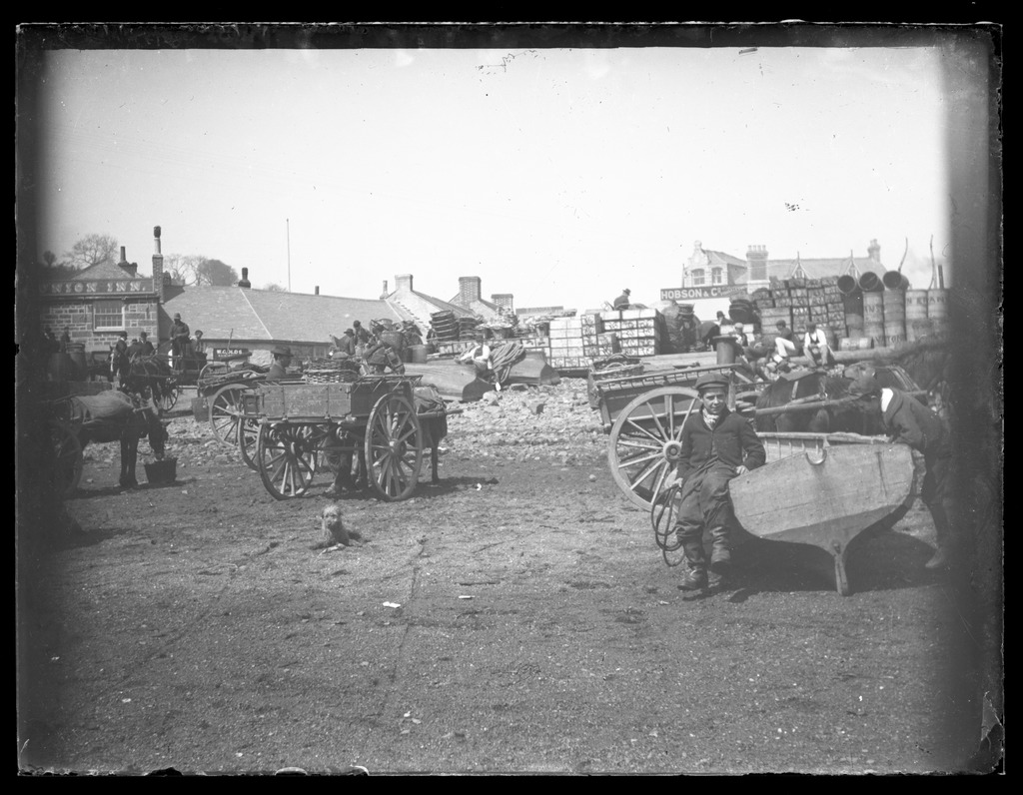
Tourism (6.0)
Figure 6.0: Jersey Car leaving Penzance with Tourists, 1920.
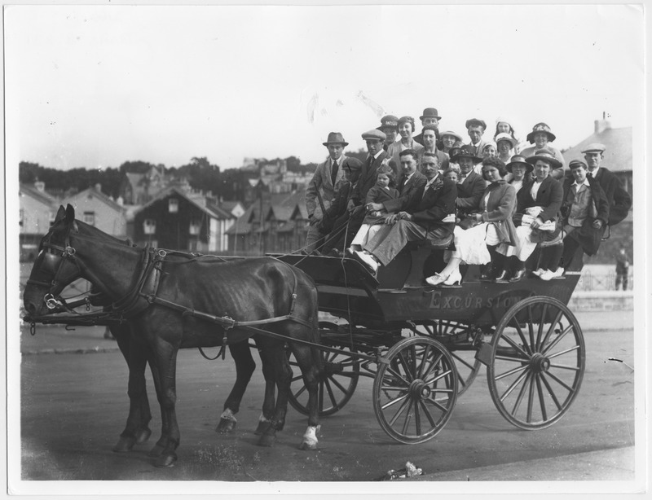

Figure 6.1: Jersey Car with appx 18 Passengers, 1920.
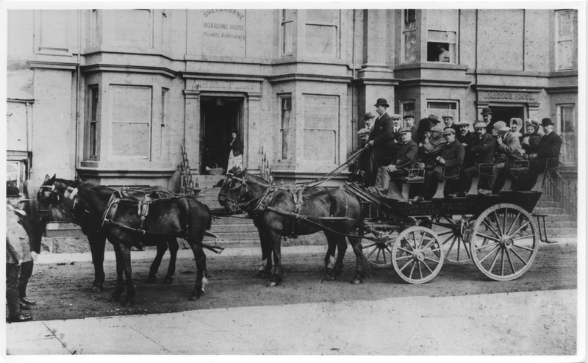
Figure 6.2: Excursion leaving Penzance for Land's End, 1890.
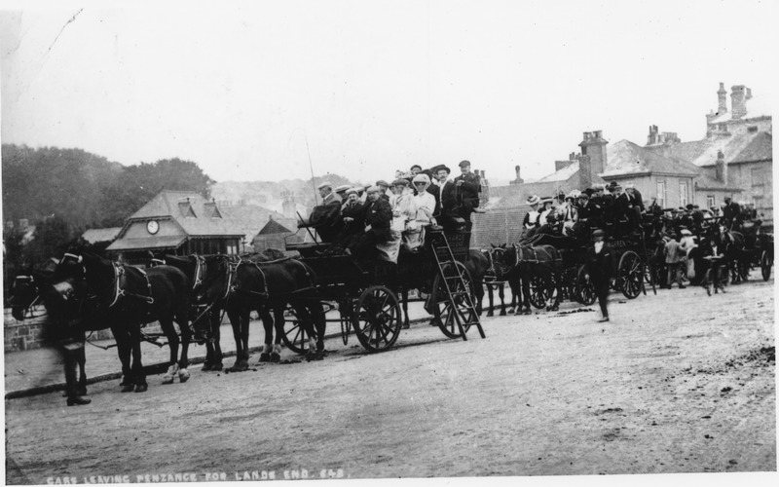

Figure 6.3: Passengers on Board Group of Posed Men in Front, 1915.
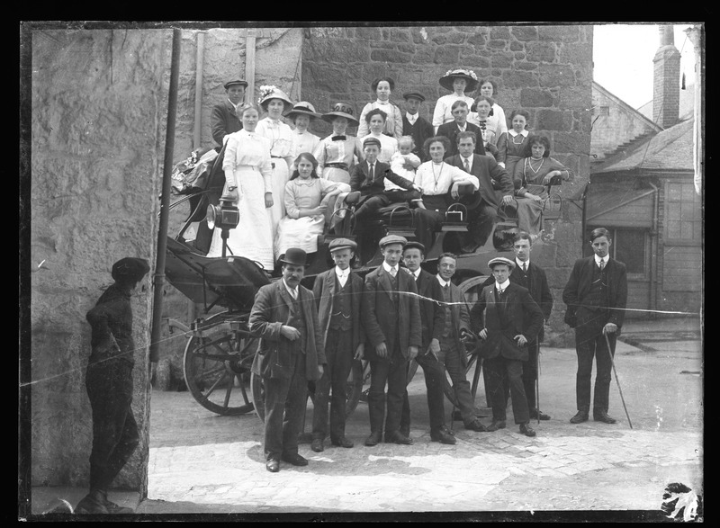

Bibliography

Primary Material
“Bathers at Battery Rocks before the Jubilee Pool, 1930s (Unknown Date)” Morrab Library Photo Archive, accessed May 24, 2026. https://photoarchive.morrablibrary.org.uk/items/show/13837.
“Building Sheds and Underwalk which is now part of Jubilee Bathing Pool, 1930s (Unknown Date),” Morrab Library Photo Archive, accessed May 24, 2026. https://photoarchive.morrablibrary.org.uk/items/show/5095.
“Camberwell Street, Penzance. Boat Built in his backyard by Mr Ellis, 1906.” Morrab Library Photo Archive accessed May 24, 2026. https://photoarchive.morrablibrary.org.uk/items/show/11587.
“Excursion leaving Penzance for Land's End,” Morrab Library Photographic Archive, accessed July 6, 2026, https://photoarchive.morrablibrary.org.uk/items/show/10750.
“Fishermen and Girl on Rocks at Cape Cornwall, 1890,” Morrab Library Photo Archive, accessed May 24, 2026. https://photoarchive.morrablibrary.org.uk/items/show/11200.
“Fish Co Offices Newlyn Market Fish Auction Table, 1930.” Morrab Library Photographic Archive accessed July 6, 2026, https://photoarchive.morrablibrary.org.uk/items/show/6881.
“Fish Jowster Billy Renfree believed to be member,” Morrab Library Photographic Archive, accessed July 6, 2026, https://photoarchive.morrablibrary.org.uk/items/show/4711.
“Fish Market, 1930s (Unknown Date).” Morrab Library Photographic Archive, accessed July 6, 2026, https://photoarchive.morrablibrary.org.uk/items/show/20949.
“Fish preparation with seagulls, Newlyn.” Morrab Library Photographic Archive accessed July 3, 2026, https://photoarchive.morrablibrary.org.uk/items/show/22944.
“Fish Vendor Lizzie Boynes on her Donkey Cart,” Morrab Library Photographic Archive, accessed July 6, 2026, https://photoarchive.morrablibrary.org.uk/items/show/8677.
Gibson, “Cornish Fishwives,” Morrab Library Photographic Archive, accessed July 7, 2026, https://photoarchive.morrablibrary.org.uk/items/show/18977.
“Group fishermen and boys,” Morrab Library Photographic Archive, accessed June 22, 2026, https://photoarchive.morrablibrary.org.uk/items/show/4671.
“Group of fishermen on a bench near old harbour,” Morrab Library Photographic Archive, accessed July 2, 2026, https://photoarchive.morrablibrary.org.uk/items/show/9334.
“Group fishermen outside fish cellar Porthgwarra,” Morrab Library Photographic Archive, accessed June 22, 2026, https://photoarchive.morrablibrary.org.uk/items/show/11198.
“Group looking at Basking Shark, Lighthouse Pier, Newlyn, 1926.” Morrab Library Photo Archive accessed May 24, 2026.https://photoarchive.morrablibrary.org.uk/items/show/11280.
“Group of young and old men sitting,” Morrab Library Photographic Archive, accessed July 2, 2026, https://photoarchive.morrablibrary.org.uk/items/show/18224.
“Gwavas Quay, Newlyn, 1895,” Morrab Library Photo Archive, accessed May 24, 2026. https://photoarchive.morrablibrary.org.uk/items/show/16623.
“Ice Cream Vendor with Hand Drawn Cart Pz Prom,” Morrab Library Photographic Archive, accessed July 6, 2026, https://photoarchive.morrablibrary.org.uk/items/show/8672.
“Jersey Car leaving Penzance with Tourists, 1920,” Morrab Library Photographic Archive, accessed July 6, 2026, https://photoarchive.morrablibrary.org.uk/items/show/8738.
“Jersey Car with appx 18 Passengers, 1920,” Morrab Library Photographic Archive, accessed July 6, 2026, https://photoarchive.morrablibrary.org.uk/items/show/8129.
“Landing Fish at Newlyn, 1890.” Morrab Library Photo Archive accessed May 24, 2026. https://photoarchive.morrablibrary.org.uk/items/show/20953.
“Large Crowds Celebrating the Opening of North Pier, Newlyn, 1893.” Morrab Library Photo Archive accessed May 24, 2026. https://photoarchive.morrablibrary.org.uk/items/show/11083.
“May Hornes, Penzance,” Morrab Library Photographic Archive, accessed July 6, 2026, https://photoarchive.morrablibrary.org.uk/items/show/13539.
“Passengers on board group of posed men in front,” Morrab Library Photographic Archive, accessed July 6, 2026, https://photoarchive.morrablibrary.org.uk/items/show/10630.
“People watching a Female Artist in Mousehole, 1930s (Unknown Date),” Morrab Library Photo Archive, accessed May 24, 2026. https://photoarchive.morrablibrary.org.uk/items/show/20035.
“Postcard: Whales stranded in Mount’s Bay, 1911.” Morrab Library Photo Archive accessed May 24, 2026. https://photoarchive.morrablibrary.org.uk/items/show/16793.
“Postcard: Whales stranded in Mount’s Bay, 1911.” Morrab Library Photo Archive accessed May 24, 2026. https://photoarchive.morrablibrary.org.uk/items/show/16792.
Preston, Robert H. “Cornish Fish Woman, 1902-7.” Morrab Library Photographic Archive, accessed July 7, 2026, https://photoarchive.morrablibrary.org.uk/items/show/3856.
“Procession up Market Jew Street, Penzance celebrating the end of WW1.” Morrab Library Photographic Archive accessed July 2, 2026, https://photoarchive.morrablibrary.org.uk/items/show/5158.
“PZ 109 Capsized,” Morrab Library Photographic Archive, accessed July 3, 2026, https://photoarchive.morrablibrary.org.uk/items/show/20400.
“Newlyn,” Morrab Library Photographic Archive, accessed July 3, 2026, https://photoarchive.morrablibrary.org.uk/items/show/18941.
“Newlyn fishermen mending nets, 1890,” Morrab Library Photographic Archive, accessed July 3, 2026, https://photoarchive.morrablibrary.org.uk/items/show/16497.
“Newlyn Fishwives, 1930.” Morrab Library Photographic Archive, accessed July 7, 2026, https://photoarchive.morrablibrary.org.uk/items/show/3762.
“Selling Fish from Horse and Cart St Ives,” Morrab Library Photographic Archive, accessed July 6, 2026, https://photoarchive.morrablibrary.org.uk/items/show/10030.
“Selling Fish from Horse and Cart St Ives,” Morrab Library Photographic Archive, accessed July 6, 2026, https://photoarchive.morrablibrary.org.uk/items/show/15778.
“Sennen Fishermen clearing a Pilchard net.,” Morrab Library Photographic Archive, accessed July 3, 2026, https://photoarchive.morrablibrary.org.uk/items/show/5060.
“Shipwreck the ‘Jeune Hortense,’ 1888,” Morrab Library Photo Archive, accessed May 24, 2026. https://photoarchive.morrablibrary.org.uk/items/show/14189.
“Strand area at Street-an-Nowan, Newlyn, 1895-1900,” Morrab Library Photographic Archive, accessed July 7, 2026, https://photoarchive.morrablibrary.org.uk/items/show/17669.
“Street view. Mousehole. women carrying pails, 1915 ,” Morrab Library Photographic Archive, accessed July 7, 2026, https://photoarchive.morrablibrary.org.uk/items/show/4674.
“Thatched Shops in Market Jew Street.,” Morrab Library Photographic Archive, accessed July 6, 2026, https://photoarchive.morrablibrary.org.uk/items/show/21032.
“Three men,” Morrab Library Photographic Archive, accessed June 22, 2026, https://photoarchive.morrablibrary.org.uk/items/show/20929.
“Three Fishermen sitting on a bench by a wall,” Morrab Library Photographic Archive, accessed July 2, 2026, https://photoarchive.morrablibrary.org.uk/items/show/8976.
“Three fishermen on deck of storm damaged ketch,” Morrab Library Photographic Archive, accessed July 3, 2026, https://photoarchive.morrablibrary.org.uk/items/show/11481.
“Treworveneth St fishwives, 1890,” Morrab Library Photographic Archive, accessed July 7, 2026, https://photoarchive.morrablibrary.org.uk/items/show/16411.
“Two fishwives,” Morrab Library Photographic Archive, accessed July 7, 2026, https://photoarchive.morrablibrary.org.uk/items/show/11199.
“Two Women, One Man outside cottage, 1900 (Unknown Date)” Morrab Library Photographic Archive, accessed July 7, 2026, https://photoarchive.morrablibrary.org.uk/items/show/19016.
Wharton's Series. “Fishwives in Church Street, Newlyn Town, 1907.” Morrab Library Photographic Archive, accessed July 7, 2026, https://photoarchive.morrablibrary.org.uk/items/show/4597.
“Women & Children in The Digey St Ives,” Morrab Library Photographic Archive, accessed July 7, 2026, https://photoarchive.morrablibrary.org.uk/items/show/7033.
“Wreck of Caroline Parsons Lifeboat, 1935.” Morrab Library Photo Archive accessed May 24, 2026. https://photoarchive.morrablibrary.org.uk/items/show/19365.
Wreck of ‘Cecelia’, 1935.” Morrab Library Photo Archive accessed May 24, 2026. https://photoarchive.morrablibrary.org.uk/items/show/19366.

Secondary Material
Bennet, G.H and R. “Maritime Cornwall in the Era of Two World Wars.” in The Maritime History of Cornwall, edited by Philip Payton, Alston Kennerley, and Helen Doe, 507-521. Exeter: University of Exeter, 2014.
Burton, Valerie. “Fish/Wives: An Introduction.” Signs 37 (2012): 527-536.
Bourke, Joanna. Working-Class Cultures in Britain, 1890-1960: Gender, Class and Ethnicity. London: Routledge, 1994.
Corin, John. Fishermen’s Conflict: The Story of Newlyn. Newton Abbot: David & Charles.
Frost, Ginger S. Victorian Childhoods. Vienna: Praeger, 2008.
Edge, Sarah. The Extraordinary Archive of Arthur J. Munby: Photographing Class and Gender in the Nineteenth Century. London: Routledge, 2015.
Harris, Keith. Hevva! Cornish Fishing Industry in the Days of Sail. Redruth: Dyllansow Truran, 1983.
Pawlyn, Tony. “The Cornish Sea Fisheries in the Nineteenth Century.” in The Maritime History of Cornwall edited by Philip Payton, Alston Kennerley, and Helen Doe, 543-569. Exeter: University of Exeter, 2014.
Payton, Philip. “Twentieth-Century Maritime Tourism and Recreation.” in The Maritime History of Cornwall, edited by Philip Payton, Alston Kennerley, and Helen Doe, 507-521. Exeter: University of Exeter, 2014.
Rose, Sonya O. Limited Livelihoods: Gender and Class in the Nineteenth Century. London: Routledge, 1992.
Tinkler, Penny. Using Photography in Social and Historical Research. London: Sage, 2013.

Penny Tinkler, Using Photographs in Social and Historical Research (London: Sage, 2013), 3.
Tinkler, Using Photographs in Social and Historical Research, 3.
Ibid, 10.
Joanna Bourke, Working-Class Cultures in Britain, 1890-1960: Gender, Class and Ethnicity (London: Routledge, 1994), 114.
“Group fishermen outside fish cellar Porthgwarra,” Morrab Library Photographic Archive, accessed June 22, 2026; “Three men, 1890” Morrab Library Photographic Archive; accessed June 22, 2026; “Group fishermen and boys,” Morrab Library Photographic Archive, accessed June 22, 2026.
Bourke, Working-Class Cultures in Britain, 1890-1960, 115.
“Group of young and old men sitting, 1920” Morrab Library Photographic Archive, accessed July 2, 2026; “Three Fishermen sitting on a bench by a wall, 1925” Morrab Library Photographic Archive, accessed July 2, 2026; “Group of fishermen on a bench near old harbour,” Morrab Library Photographic Archive, accessed July 2, 2026.
G.H and R. Bennet, “Maritime Cornwall in the Era of Two World Wars,” in The Maritime History of Cornwall, ed.by Philip Payton, Alston Kennerley, and Helen Doe (Exeter: University of Exeter, 2014), 483.
G.H and R. Bennet, Maritime Cornwall in the Era of Two World Wars, 483.
Ibid, 483.
Procession up Market Jew Street, Penzance celebrating the end of WW1.,” Morrab Library Photographic Archive, accessed July 2, 2026; “Gathering at Alverton St, organisations involved in WW1,” Morrab Library Photographic Archive, accessed July 2, 2026.
“Victory Arch Wherrytown looking towards Newlyn,” Morrab Library Photographic Archive, accessed July 2, 2026.
Sonya O. Rose, Limited Livelihoods: Gender and Class in the Nineteenth Century (London: Routledge, 1992), 77
Valerie Burton, “Fish/Wives: An Introduction,” Signs 37 (2012): 532.
Robert H Preston, “Cornish Fish Woman, 1902-7,” Morrab Library Photographic Archive, accessed July 7, 2026; “Two fishwives,” Morrab Library Photographic Archive, accessed July 7, 2026; Gibson, “Cornish Fishwives,” Morrab Library Photographic Archive, accessed July 7, 2026.
Ibid.
“Strand area at Street-an-Nowan, Newlyn, 1895-1900,” Morrab Library Photographic Archive, accessed July 7, 2026; “Newlyn Fishwives.,” Morrab Library Photographic Archive, accessed July 7, 2026.
“Treworveneth St fishwives, 1890,” Morrab Library Photographic Archive, accessed July 7, 2026; Wharton's Series, “Fishwives in Church Street, Newlyn Town.,” Morrab Library Photographic Archive, accessed July 7, 2026.
Sarah Edge, The Extraordinary Archive of Arthur J. Munby: Photographing Class and Gender in the Nineteenth Century (London: Routledge, 2015), 23.
“Street view. Mousehole. women carrying pails, 1915,” Morrab Library Photographic Archive, accessed July 7, 2026; “Women & Children in The Digey St Ives, 1900,” Morrab Library Photographic Archive, accessed July 7, 2026.
“Two Women, One Man outside cottage, 1900 (Unknown Date)” Morrab Library Photographic Archive, accessed July 7, 2026.
Edge, The Extraordinary Archive of Arthur J. Munby: Photographing Class and Gender in the Nineteenth Century, 27.
Ginger S. Frost, Victorian Childhoods (Vienna: Praeger, 2008), 5.
Frost, Victorian Childhoods, 55.
“Landing Fish at Newlyn, 1890,” Morrab Library Photo Archive, accessed May 24, 2026.
“Fishermen and Girl on Rocks at Cape Cornwall, 1890,” Morrab Library Photo Archive, accessed May 24, 2026.
“Gwavas Quay, Newlyn, 1895,” Morrab Library Photo Archive, accessed May 24, 2026.
“Camberwell Street, Penzance. Boat Built in his backyard by Mr Ellis, 1906.” Morrab Library Photo Archive, accessed May 24, 2026.
Ibid.
“Shipwreck the ‘Jeune Hortense,’ 1888,” Morrab Library Photo Archive, accessed May 24, 2026.
“Wreck of ‘Cecelia’, 1935.” Morrab Library Photo Archive, accessed May 24, 2026.
“Wreck of Caroline Parsons Lifeboat, 1935.” Morrab Library Photo Archive, accessed May 24, 2026.
“Postcard: Whales stranded in Mount’s Bay, 1911,” Morrab Library Photo Archive, accessed May 24, 2026; “Postcard: Whales stranded in Mount’s Bay, 1911.” Morrab Library Photo Archive, accessed May 24, 2026.
“Group looking at Basking Shark, Lighthouse Pier, Newlyn, 1926.” Morrab Library Photo Archive, accessed May 24, 2026.
“Large Crowds Celebrating the Opening of North Pier, Newlyn, 1893.” Morrab Library Photo Archive, accessed May 24, 2026.
“Building Sheds and Underwalk which is now part of Jubilee Bathing Pool, 1930s (Unknown Date),” Morrab Library Photo Archive, accessed May 24, 2026.
“Bathers at Battery Rocks before the Jubilee Pool, 1930s (Unknown Date)” Morrab Library Photo Archive, accessed May 24, 2026.
“People watching a Female Artist in Mousehole, 1930s (Unknown Date),” Morrab Library Photo Archive, accessed May 24, 2026.
Keith Harris, Hevva! Cornish Fishing Industry in the Days of Sail (Redruth: Dyllansow Truran, 1983), 3.
Harris, Hevva!, 4.
“Newlyn,” Morrab Library Photographic Archive, accessed July 3, 2026; “Sennen Fishermen clearing a Pilchard net.,” Morrab Library Photographic Archive, accessed July 3, 2026; “Newlyn fishermen mending nets, 1890,” Morrab Library Photographic Archive, accessed July 3, 2026.
John Corin, Fishermen’s Conflict: The Story of Newlyn (Newton Abbot: David & Charles), 3.
“PZ 109 Capsized,” Morrab Library Photographic Archive, accessed July 3, 2026.
“Fish preparation with seagulls, Newlyn.,” Morrab Library Photographic Archive, accessed July 3, 2026; “Three fishermen on deck of storm damaged ketch,” Morrab Library Photographic Archive, accessed July 3, 2026.
“Thatched Shops in Market Jew Street, 1880-1882,” Morrab Library Photographic Archive, accessed July 6, 2026; “Fruit & Veg Stalls alongside Market House,1925,” Morrab Library Photographic Archive, accessed July 6, 2026.
Ibid.
“Fish Jowster Billy Renfree believed to be member,1900,” Morrab Library Photographic Archive, accessed July 6, 2026; “Fish Vendor Lizzie Boynes on her Donkey Cart, 1900,” Morrab Library Photographic Archive, accessed July 6, 2026,
“May Hornes, Penzance, 1930,” Morrab Library Photographic Archive, accessed July 6, 2026; “Ice Cream Vendor with Hand Drawn Cart Pz Prom, 1920,” Morrab Library Photographic Archive, accessed July 6, 2026.
Tony Pawlyn, “The Cornish Sea Fisheries in the Nineteenth Century,” in The Maritime History of Cornwall ed.by Philip Payton, Alston Kennerley, and Helen Doe (Exeter: University of Exeter, 2014), 559.
Selling Fish from Horse and Cart St Ives, 1935, Morrab Library Photographic Archive, accessed July 6, 2026; Selling Fish from Horse and Cart St Ives, 1935, Morrab Library Photographic Archive, accessed July 6, 2026.
Fish Co Offices Newlyn Market Fish Auction Table, 1930, Morrab Library Photographic Archive, accessed July 6, 2026; “Fish Market,” Morrab Library Photographic Archive, accessed July 6, 2026.
Philip Payton, “Twentieth-Century Maritime Tourism and Recreation,” in The Maritime History of Cornwall ed.by Philip Payton, Alston Kennerley, and Helen Doe (Exeter: University of Exeter, 2014), 506.
Ibid, 506.
“Jersey Car leaving Penzance with Tourists, 1920,” Morrab Library Photographic Archive, accessed July 6, 2026; “Jersey Car with appx 18 Passengers, 1920,” Morrab Library Photographic Archive, accessed July 6, 2026: “Excursion leaving Penzance for Land's End,” Morrab Library Photographic Archive, accessed July 6, 2026.
“Passengers on board group of posed men in front,” Morrab Library Photographic Archive, accessed July 6, 2026.

